“Sahajjer Hat”A pick and place robotic System For Assistance Of People

**Abstract**

Humanity has always attempted to give life to its artifacts as features in an attempt to find substitutes for itself to fulfill its directions and also to function in a hostile setting. A machine that looks like a human arm and works like it is the popular concept of a mechanical arm.

The industry is moving from the current state of automation to robotization. Increase productivity and consistent quality production.The industrial robots of today may not look at all like a human being, although the whole research aims to provide more and more anthropomorphic and human-like features and superhuman capacity in this work unravels the fact that man would always want to adhere to precautions for safety at work and even in his environment.Managing certain specific responsibilities. Like sending a robotic car to hazardous settings for chemical analysis specimens. A typical robotic car can travel and cross obstacles across distinct terrains.

A robotic manipulator or just a mechanical arm is one robot type that is commonly used in industry. It is an open or closed kinematic chain of stiff links interconnected by mobile joints. In some environments, links can be considered as waist to match human anatomy. Upper arm with joint and forearm of the shoulder and elbow.At the end of the arm, a wrist joint connects an end-effector that can be an tool with which to function, or a gripper or any other device.

The primary objective of this project is to create an industry / restaurant pick-and-place robot as an option for human employees. Compared to others, this scheme works correctly. The one portion of our project is the robotic vehicle and the other portion is the robotic arm component.The robotic vehicle is governed by voice, while the other is controlled by a joystick, which is the robotic arm. Thus it makes the pick and place robotic arm perfectly mobile. This project results in our hard work and commitment.

*Keywords-* Arduino, Servo motors, Robotic arm, Controller, Programming of the Arduino.

**Table of Content**

**Chapter 1 ………………………………………………………………………………………13**

**Overview**

**1.1** **Introduction………………………………………………………………………......14**

**1.2** **Project Description……………………………………………………………………14**

**1.3** **Literature Review……..……………………………………………………………..16**

**1.4** **Project Goal………………………………………………………………………...…17**

**1.5** **Project claims…………………………………………………………………………..18**

**1.6 Summary……………… ………………………………………………………….…18**

**Chapter 2…………………………………………………………………………………………..19**

**Motivation**

**2.1 Introduction…………………………………………………………………………....…..20**

**2.2 Motivation towards our projects…………………………………………………...….....20**

**2.3 Summary……….…………………………………………………………………..….......20**

**Chapter 3…………………………………………………………………………….………….......21**

**Existing Systems**

**3.1** **Introduction ……………………….………………………………………………….…22**

**3.2** **Similar Existing System……………………………….……………………………...…22**

**3.3** **Summary….………………………………………………………………………...……23**

**Chapter 4…………….………………………………………………………………………..…....24**

**Technical Description**

**4.1** **Introduction……..……………………………………………………………………..…25**

**4.2** **System Description…………………….………………………………….…………..…25**

**4.2.1Arduino Uno……………………………………………………….…….………….…25**

**4.2.2Arduino Mega……………………………………………………………….......…….25**

**4.2.3Bluetooth HC-05……………………………………………………………………...26**

**4.2.4L293D Ic……………………………………………………………………..…...…27**

**4.2.5 Gear Motor………………………………………………………………………….28**

**4.2.6Servo Motor…………………………………………………………………..……..28**

**4.2.7Robotic Chassis……………………………………………………….……………..29**

**4.2.8 Robotic Arm Kit………………………………………………...…..………………30**

**4.2.9 Joystick Controller…………………………………………….…………………….30**

**4.2.10 PCA9685 16 Channel Module……………………………………………………...33**

**4.2.11 Dc-Dc Boost Converter…………………………………………………….……….34**

**4.2.12 Battery ……………………………………………………..……………….……….34**

**4.2.13 Wires………………………………………………………………………………….35**

**4.3 Summary……………………………………………………………………………………36**

**Chapter 5……..……………………………………………………………………………….....34**

**Design Implementation**

**5.1Introduction…………………………………………………….…………………………..37**

**5.2 List of necessary hardware components…………………………………………..……...38**

**5.3 Description of operation…………………………………………………………………...38**

**5.3.1 Robotic Vehicle….……..……………………………………………………………...38**

**5.3.2 Robotic Arm………… ……………………………………………………………......39**

**5.4 Principle of Operation………………………………………………………………………40**

**5.5 Summary…………………………………………………………………………………….41**

**Chapter 6 ………………………………………………………………………………………....42**

**Technical Details**

**6.1Introduction………………………………………………….……………………………43**

**6.2 Technical Details…………………………………………………………………………..43**

**6.2.1 Implementation of robotic vehicle…………………………………………………..43**

**6.2.2 Implementation of robotic arm……………………………………………………...45**

**6.3 Skills required…………………………………………..………………………………….47**

**6.4 Summary…………………………………………………………………………………..48**

**Chapter 7 ………………………………………………………………………………………49**

**Result Analysis**

**7.1 Introduction……………………………………………………………………………..50**

**7.2 Result and Analysis……………………………………………………………………..50**

**7.3 Difficulties faced and Solution…………………………………………………………50**

**7.4 Summary………………………………………………………………………………...51**

**Chapter 8 ………………………………………………………………………………………52**

**Risk Factors, Applications, Advantages & Disadvantages**

**8.1Introduction……………………………………………………..………………………53**

**8.2 Risk Factors………………..………….…………………………………………………53**

**8.3 Solutions…………………………………………………………………………….…..54**

**8.4 Applications ……………………………………………………………………………..54**

**8.5 Advantages………………………………………………………………………………56**

**8.6 Disadvantages……………………………………………………………………………57**

**8.7 Summary…………………………………………………………………………………58**

**Chapter 9 …………………………….……………………………………………….............59**

**Work Structure**

**9.1Introduction……………………………………………………………………………60**

**9.2Work Breakdown Structure…………………………………………….…………….60**

**9.3Cost Of Implementation…………………………………………………..…………..61**

**9.4Feasibility Study………………………………………………………………………62**

**9.5 Summary……………………………………………………………….………………62**

**Chapter 10 ………………………………………………………………………………..….63**

**Future Scope of Work**

**10.1 Introduction……………….…………………………………………………………64**

**10.2 Future Scope Of work………………………………………………………………64**

**10.3 Summary……………………………………………………………………………….64**

**Chapter 11……………………………………………………………………………………65**

**Design Impact**

**11.1 Introduction……………………………………………………………………………66**

**11.2 Economic Impact……………………………………………………………………...66**

**11.3 Social Impact…………………………………………………………………………..66**

**11.4 Health and safety Impact……………………………………………………………..66**

**11.5 Environmental Impact………………………………………………………………..67**

**11.6 Ethical Impact………………………………………………………………………...67**

**11.7 Manufacturability…………………………………………………………………….67**

**11.8 Summary……………………………………………………………………………....68**

**Chapter 12……………………………………………………………………………………...69**

**Sustainability and necessity**

**12.1 Introduction………………………………………………………………………...….70**

**12.2 Sustainability…………………………………………………………………………..70**

**12.3 Is it actually needed?......................................................................................................70**

**12.4 Why people will buy our project?...............................................................................71**

**12.5 Summary………….……………………………………………………………..……..72**

**Chapter 13………………………………………………….………………………..………….73**

**Compliance with Standards**

**13.1 Introduction………………………………………………………………………...….74**

**13.2 Compliance with IEEE Standards……………………………………….…..………74**

**13.3 US compliance Standards...……………………………………………………….…75**

**13.4 European compliance Standards …………………………………………………….75**

**13.5 Summary…………………………………………………………………………….…75**

**Chapter 14………………………………………………………………………………………76**

**Conclusion………………………………………………………………………………………..76**

**Bibliography………………………………………………………………………………………78**

**Appendices……………………………………………………………………………………….80**

**Appendix ………………………………………………………………………….……..……81**

**List of Figures**

|  |  |  |
| --- | --- | --- |
| ***Fig No.*** | ***Figure Caption*** | ***Page No.*** |
|  |  |  |
| ***1.1*** | Block Diagram (Moving Body) | 12 |
| ***1.2*** |  |  |
| The free movement of our robotic arm | 13 |
| ***2.1*** |  |  |
| Industrial Robots | 20 |
| ***4.1*** |  |  |
|  |  |
| Arduino Uno | 22 |
| ***4.2*** |  |  |
| Arduino Mega | 23 |
| ***4.3*** |  |  |
| HC-05 Module | 24 |
| ***4.4*** |  |  |
| IC Diagram of L293D | 25 |
| ***4.5*** |  |  |
| Gear Motor | 25 |
| ***4.6*** |  |  |
| Servo Motor | 26 |
| ***4.7*** |  |  |
| Robotic arm kit | 27 |
| ***4.8*** |  |  |
| PS2 Controller | 28 |
| ***4.9*** |  |  |
| PS2 Controller receiver pins | 29 |
| ***4.10*** |  |  |
| PCA9685 Channel Module | 30 |
| ***4.11*** |  |  |
| DC-DC Boost converter | 32 |
| ***4.12*** |  |  |
| Battery | 32 |
| ***4.13*** |  |  |
| Wires | 33 |
| ***5.1*** |  |  |
| Robotic Vehicle | 35 |
| ***5.2*** |  |  |
| Principle of operation | 37 |
| ***6.1*** |  |  |
| Circuit diagram (Robotic Vehicle) | 41 |
| ***6.2*** |  |  |
| Circuit Diagram of Robotic Arm | 43 |
| ***11.1*** |  |  |
| Influence of different things in a project | 65 |

**List of Tables**

|  |  |  |
| --- | --- | --- |
|  |  |  |
| Serial no: | ***Caption of table*** | **Page NO:** |
| 01. | Arduino to servo motor connection | 31 |
| 02. | HC-05 to Arduino Connection | 40 |
| 03 | PS2 Receiver to Arduino Mega | 42 |
| 04 | Control of the servo motors | 44 |
| 05 | Work plan | 57 |
| 06 | Cost of equipment | 58 |

**Overview**

* 1. **Introduction:**

Robot is a high-precision machine that performs distinct tasks constantly. Hence many functions such as gathering data and research on dangerous locations that are too dangerous to send people inside. Robots are used to decrease almost 50 percent of human intervention. Robots are used in various kinds such as robot fire detection, robot metal detection, etc. In the 1950s, "UNIMATE" was the first robotic arm to be used in an automotive industry in GM motors USA. Research and growth in robotics has since been tremendously improved. Robots are now an essential component of nearly every industry. Robots are required to perform various duties including welding, trimming, picking and placement, etc. These robots are managed in various ways, such as keypads, voice control, etc.

The project is intended with a smooth catching gripper to create a pick n place robotic vehicle. For instance, to prevent explosion while catching, it can manage a bomb very closely. The robotic vehicle is remote-operated joystick controlled. Using joystick, commands are sent to the receiver at the transmitting end to either regulate the robot's motion to move forward, backward, left, or right, etc. Four engines are interfaced with the microcontroller at the receiving end where two are used for the robot's arm and gripper motion while the other two are used for body motion. The joystick device transmitter functions as a remote control that has the benefit of appropriate range, while the Bluetooth receiver end unit is supplied to the microcontroller to drive DC motors for the needed job via motor driver IC.

The primary benefit of this robot is its smooth catching arm, which is intended for security purposes to prevent additional stress on the item to carry. Our project seeks to design a robot that is wirelessly operated by the user and capable of selecting and placing many items for individuals with physical disabilities. We need to create 6-axis robotic hand gripper to pick and place items for physically disabled individuals. Hand gripper control is also by voice command. This will be very useful for disabled individuals. We can also use the robot for business purposes. We researched a few papers and publications to collect some data and more knowledge about our project. The project can also be improved by making it autonomous. It is possible to add the cameras and IR detector to the project for this. Using picture acquisition method, cameras are used to identify objects and reverse cinematics and IR detector can be used to identify object distance.

**1.2 Project Description:**

Nowadays, the grace of improving contemporary equipment like mobile phones, robot, computer etc. has made our daily lives simpler than the past. People are predominantly device dependent. Personal robotic assistants assist to reduce people's manual attempts in their daily duties.We will create a personal assistant robot that is controlled by android. The commands will be provided remotely to the robotic assistant, which can be governed by joystick using a intelligent mobile phone and robotic arm. The robot can conduct various motions, turns, start/stop operation, and move an object from one location to another.The commands will be communicated to the robot over a Bluetooth network. The personal assistant robot will be developed on a micro-controller based platform and can be aware of its current location. The effectiveness of the android control communicated over a distance is measured through several experiments.We also used the joystick experiment to make the robotic arm gripper more effective.

1. **Significance of the device**

This project Android Controlled Robotic system helps to control robot through commands received via android application. The integration of control unit with Bluetooth device is done to capture and read the commands. The robotic vehicle then operates as per the command received via android application.The movement of the robotic arm will be controlled via joystick controller so that it will be more work efficient.The significant side of this device is it is cost effective and it will be helpful for those restaurants or industries where there is a lack of human power .They can use this device instead of human worker. Thus this device will help us to save money and also work randomly.

1. **Design of the System**

What we intended to do in this project is making a Android controlled Pick and Place Robot using the knowledge of Arduino, Bluetooth module and Inverse kinematics. These are the major knowledge we require in this project. Apart from that the knowledge of coding is also required for making this robot as it is a mixture of software and hardware both. This project relates to a robot which will take command from the android device and joystick controller.For the voice commands we will use an android app which we have developed. First the android phone needs to be paired to the Bluetooth and then it will take commands.We also programmed the robotic arm in such a way that it will take commands from a wireless joystick thus it will work more effectively.

1. **Block Diagram**

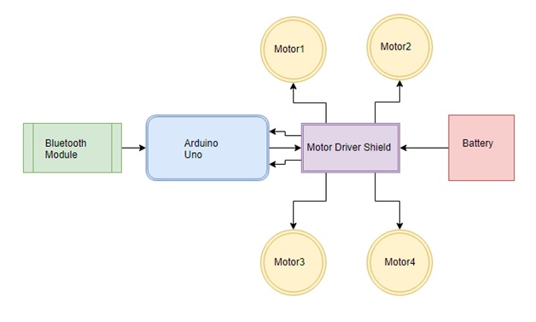

Fig 1.1 :Block Diagram(Moving Body)

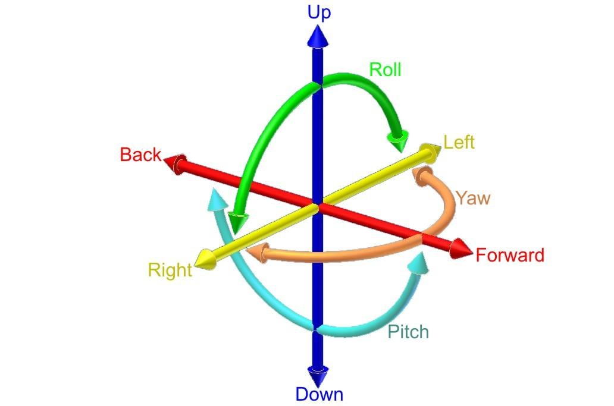

Fig1.2:The free movement of our robotic arm.

**1.3 Literature Review**

Personal robotic assistants help reducing the manual efforts being put by humans in their day-to-day tasks. We will develop a voice& joystick controlled personal assistant robot. The human voice commands are given to the robotic assistant remotely, by using a smart mobile phone. The robot can perform different movements, turns, start/stop operation and relocate an object from one place to another. The speech signal commands converted to text form are communicated to the robot over a Bluetooth network. The robotic arm consists of various servo motors and it has been tested by using the joystick controller many a times begore it has been implemented.

We used Arduino Uno for the robotic vehicle part and the Arduino mega for the robotic arm gripper because although the vehicle had 4 motors the robotic arm consists of several servo motors which needs to be perfectly controlled in order for the project to run smoothly and efficiently.

Depending on the implementation, the robotic arm can be intended to conduct any required job like welding, gripping, spinning, etc. For instance, robot arms conduct a range of functions during assembly in the automotive assembly line, such as wielding and rotation of components and positioning.The robot arms can be autonomous or manually controlled and can be used with excellent precision to conduct a range of functions. The robotic arm can be mobile or fixed and can be designed for industrial or home use. Robotic hands often have built-in pressure sensors that tell the computer how hard a robot captures a specific object.They used the Microcontroller to design the Robotic Arm. Using Arduino programming, ATMEGA8 microcontroller. Using the Arduino board, this method operates on the principle of interfacing servos and potentiometers. The remote is equipped with potentiometers and the servos are mounted on the robotic arm body.The potentiometer converts the mechanical motion into electrical motion. Therefore, when the potentiometers move away, the electrical pulses are produced. The board then processes the received signals from the potentiometers and finally converts them into the required digital pulses which are then sent to the servomotors.This servo will react to the pulses resulting in the timing of the arm. DC engines fitted with a servo system being used for accurate angular position control. The servomotor being used is having Stall torque.

ATmega8 is an AVR 8-BIT microcontroller with programmable Insystem capacity together with storage of Flash code. This microcontroller is up to 1000 times reprogrammable. It also features 32 working registers, execution of a single clock cycle providing up to 1MIPs / MHz. The robotic arm can be used remotely and the job can be accomplished.

There are 2 connections and 3 joints in the robotic arm. It is installed on the middle of a table or the platform on which the items should be handled. There is an electromagnet at the end of the second link and all objects are magnetically attractive. The arm range is the complete length of the two connections. The length of each link can be designed as per requirement.The arm has three degrees of liberty. Each joint is equipped with a dc geared motor for the link movement. The robot electronics consists of a PIC microcontroller, a PC with LABView installed in it, a motor drive unit, an accelerometer at the tip of the arm and a power supply. Once the robot receives the coordinate values, the angles are calculated using the reverse cinematics and the motors make the proper rotations.

## 1.4 Project Goals :

Our robotic system is governed by android device voice and joystick commands. It seeks to achieve effective monitoring in locations where high-risk human intervention such as warm or sub-zero temperature setting, warfare areas, disaster-affected area, etc.It also seeks to fulfill the job allocated by different instructions to the user. Our project objective is to design & implement low-cost Arduino-based Voice Control robot & create apps on it, and we are also focused on building a Robotic Arm with the capacity to pick and place the object as humanly instructed.

This project seeks at designing and manufacturing the pneumatic arm for cylindrical object pick and place. We conclude that the arm is manually controlled by the flawed control valve and the control direction. The joystick controller uses the helical slot system to rotate and move the arm. The model is anticipated to raise a minimum weight of 1.5 kg.

The experimental objective is to work together the mechanism of the gripper and the mechanism of the robotic vehicle working in a single pick and place robotic arm. These robots can conduct functions such as gripping, sucking, lifting, putting, releasing in a single robotic arm, as well as moving from one location to another with the assistance of the voice control app.The cycle time, ideal time, operating cost, space consumption will be reduced. In the handling scheme, it is user-friendly and efficiently used.

Our aim is to produce a lightweight robot arm with a low cost budget. We found out that the plastic material strengthened with fiber is used to prevent adverse impact on the complete weight of the arm and the production method is used for vacuum infusion. During arm shell building, local strengthened components must be included.So we searched for such a robotic arm if its available or not and luckily we found it and we used it.The must light gear reducer, harmonic drive kinds are used, but due to absence of alignment it is necessary to disassemble the gear package in order to prevent these flexible couplings.

Through automatic material handling, an automatic, servo-controlled, freely programmable, multi-purpose manipulator with several fields for handling workpieces, instruments or unique equipment, the pick and place robotic arm can decrease human effort. A lightweight robotic arm can be manufactured by using contemporary materials such as cellular titanium & nano crystalline aluminum.

**1.5 Project Claims:**

**Our project will contain:**

* + A fixed support structure.
  + A rotatable turret carried by said support structure for rotation about one axis.
  + An arm with one end part pivotally conducted by the axis to swing the arm around the second standard axis to bring the other end part of the arm through an arc of up to approximately half a circle.A working tool, such as a gripper, carried at said other end portion of said arm.
  + A robotic car which will move from one place to another which will be controlled via voice.
  + A smooth operating pick and place robot for assistance of people.
  + Long lasting and durable system which can run for a long time.

## 1.6 Summary:

We addressed our project objectives in this section. Now a days we see a lack of human power in our industrial region and restaurants. We can decrease this issue by using this device via android phone and joystick, which will decrease our costs and also save our time. Here we described the information of our project and drew a diagram on how we can implement it.

**MOTIVATION**

**2.1 Introduction**

In this section we'll address the motive we've been thinking about applying this scheme and why we've selected the field of robotics to work on apart from all other areas.

**2.2 Motivation towards our project**

The world is moving from industrial revolution to robotic revolution.The first world countries has already started to think beyond human resources.In many countries robots has already taken the place of humans in industrial and other commercial places.Being a developing country why shouldn’t we try to be like them.We also have lacking of human resources.We can avoid those by replacing them by robotic systems.So we have decide to work on a project that can be of help in both domestic and industrial areas.This is the main motivation of choosing this idea to work on.

The main function of this project is to create a pick-and-place robot controlled by android for industrial use. Around us there are several contests that are based on robotic system apps. Those events were the ones which got us to think about the concept of a android controlled pick and place robot.Statistics also indicate that robotic systems are increasing day by day in developed countries, which gave us the incentive to introduce robots of this kind in our nation.

Robotic pick-and-place automation speeds up the process of selecting and putting components in fresh places, improving manufacturing rates. Pick-and-place robots can be tailored to meet particular manufacturing demands with many end-of-arm tooling choices available. Moving big, tiny, heavy or tough goods in the factory line can be an simple job to automate.

Consistency is also an advantage of using a scheme of pick and place. If required, the robots can be readily programmed and tooled to provide various apps. An improvement in production with a pick-and-place robot scheme provides businesses with long-term savings. More pick-and-place robotic cells are being built for automation applications with advances in robots technology and affordability.

We are aiming to build a software which can easily control the pick and place robotic vehicle. Our basic idea is to develop some sort of menu driven control for our robot, where the menu is going to be android app driven. A recognition strength of a few words or a specific control system would do for such kind of jobs.A small and easily operable joystick is enough to control the robotic arm. A person interacting with such a system would not need to go from place tom place for routine jobs, which is what we wish to achieve. This leads us to our main task in the project.

**2.3 Summary**

This chapter provided the idea about the motivation towards our project which aims to develop a Android controlled pick and place robot.

## 

## EXISTING SYSTEMS

## 3.1 Introduction

There are some gadgets and equipment in the market, but they are expensive. We received a lot of instruments from China, USA and European nations when we explored the market. Most of them are very expensive, but we try to develop it at minimal cost and sell the product on the market so that it can be bought even by people with minimal financial ability.Also there are pick and place robots which are fixed and immovable but our one can not only pick and place objects but also move from one place to another.

**3.2 Similar Existing Systems**

There are a lot of robotic systems apps. Human innovation is an action involving understanding and process generation in order to create systems that solve issues and expand human capacity. Innovation, change or alteration of the natural environment to fulfill perceived human requirements, and that is what technology wants, is basically understanding and control of its setting to fulfill any need a race could have.The applications of the project can be military surveillance, picking & placing objects from one place to another, parceling robot, container lifteretc.Some existing pick and place robots are discussed below:

* **Robotic arm:** Probably the most prevalent type of pick-and-place robot is the form of robotic arm ; typically used as 5 axis robots for normal pick-and-place aircraft apps, or 6 axis robots for more complicated apps where products need horizontal twisting.
* **Cartesian**: The cartesian robot is also a very popular form of pick-and-place robot, which used to be cheaper, but is now not so frequently installed apart from injection moulders.
* **Delta**: Delta robots are installed above conveyors and are typically used for apps for high velocity pick and place.
* **Fast:**Fast pick robots are also another option for fast pick and place applications; with cycle times as fast as 150 cycles per minute.
* **Collaborative:**In recent years a wide range of different types of collaborative robots have hit the market and these are becoming increasingly used in industrial applications, but they are mostly smaller, slower robots with less of the complex functionality available. This limits their usefulness for some applications.
* **Packaging robots: These types of robots are mainly used for packaging lots of products in industries on a regular basis.This is the most common thing used now a days.**

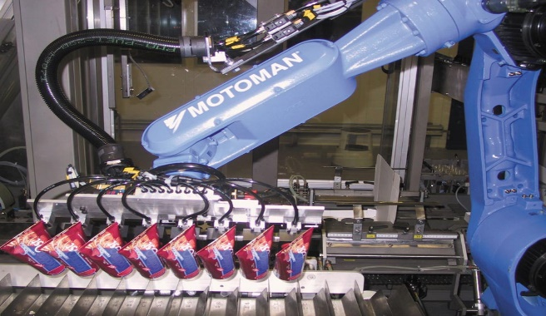

* **Industrial Robots:**Mostly heavy lifters and are used in all sorts of mechanical industries including auto mobiles.

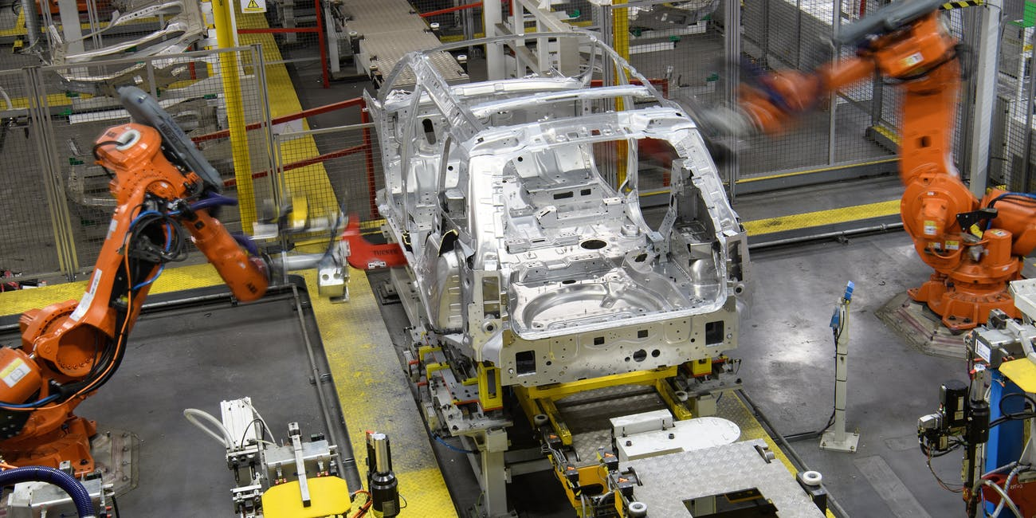

Fig2.1 Industrial Robots

## 3.3 Summary

In this chapter, we discussed about the similar systems that are being invented before by researchers or that are already existing in the society and being sold in markets for higher prices. They are costly. These devices are very costly and are not user friendly. Whereas, we will try provide product of same capability at much lesser prices.

**TECHNICAL DESCRIPTION**

**4.1 Introduction :**

We will address in this section the parts that we used for technical tasks and the execution of this project. As our project comes with different parts, we will address them one by one in this project along with their roles.

**4.2 System Description**

The entire multi-level system consists of several components which supports the project to be useful in all aspects. The components are described below for the better understanding of the project:

***4.2.1Arduino Uno:***

Arduino Uno is an ATmega328P (datasheet) based microcontroller board. It has 14 digital input / output pins (including 6 as PWM outputs), 6 analog inputs, a 16 MHz quartz crystal, a USB connection, a power jack, an ICSP header, and a reset button. It includes all the necessary to support the microcontroller; merely connect it with a USB cable to a laptop or power it with a battery."Uno" implies one in Italian and has been selected to mark Arduino Software (IDE) 1.0 release. Arduino Software (IDE)'s Uno panel and version 1.0 were Arduino's reference versions, now evolving into newer releases. The Uno panel is the first in a sequence of Arduino USB boards and the Arduino platform reference model.

The most important component for this project is Arduino. It will be programmed to response if any voice command is received via Android app. A code will be generated for the implementation and operation of the Arduino.With the help of Arduino we have programmed our robotic vehicle and it will work accordingly.

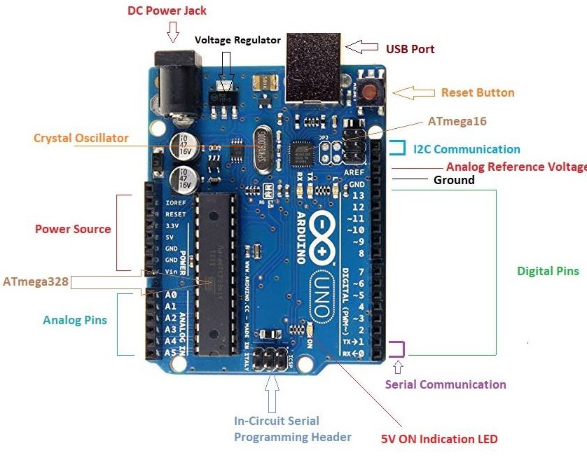

Fig 4.1: Arduino Uno

***4.2.2Arduino Mega***:

The Arduino Mega 2560 is an ATmega2560-based microcontroller board. It has 54 digital input / output pins (of which 15 can be used as PWM outputs), 16 analog inputs, 4 UARTs (serial device ports), a 16 MHz crystal oscillator, a USB connection, a power jack, an ICSP header, and a reset key.It includes everything you need to help the microcontroller ; merely connect it to a USB cable laptop or power it to get began with an AC-to-DC adapter or battery. The Mega 2560 board is consistent with most Uno and former Duemilanove or Diecimila boards constructed shields.The MEGA 2560 is intended for projects that are more complicated. It's the suggested board for 3D printers and robotics projects with 54 digital I / O pins, 16 analog inputs and a bigger room for your sketch. This provides plenty of space and possibilities to our projects.

Another most important component for this project is Arduino mega. It will be programmed to response if any command is received via joystick. A code will be generated for the implementation and operation of the Arduinomega.With the help of Arduino mega we have programmed our robotic arm gripper and it will work accordingly.

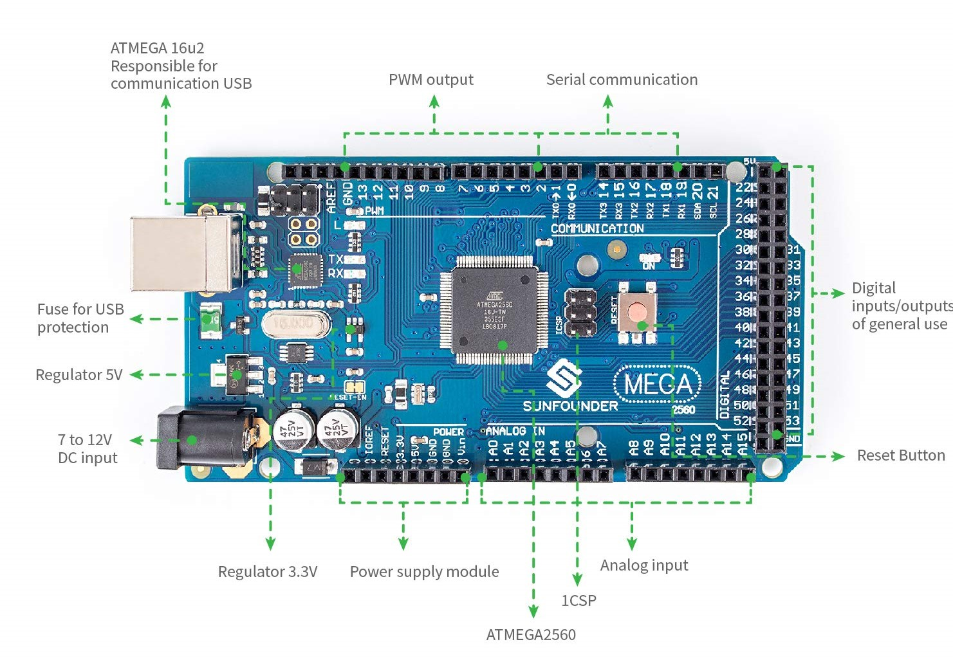

Fig 4.2:Arduino Mega.

***4.2.3Bluetooth HC-05***: Another essential part of this project is the Bluetooth module. An android device will be connected with HC-05 Bluetooth module. Android phone converts the voice into string of data using voice recognition app. This string of data was sent to HC-05 Bluetooth module and then to Arduino Uno. The developed robot is able to move in any direction according to the voice command received from the user by android phone and the Bluetooth module.

**Datasheet Of Bluetooth HC-05:**

* Operating Voltage: 4V to 6V (Typically t5V).
* Operating Current: 30mA.
* Range: <100m.
* Works with Serial communication and TTL compatible.

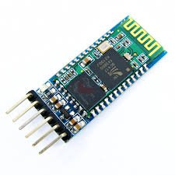

Fig 4.3: HC-05 Module

***4.2.4L293D IC:*** Another the last major component for this project is the motor driver IC. L293D is an integrated circuit (IC) dual H-bridge engine driver. Motor conductors function as present amplifiers because they receive a low-current control signal and a higher-current signal. For driving the engines, this greater present signal is used.L293D includes two H-bridge driver circuits that are integrated. Two DC motors can be pushed concurrently in their prevalent operating mode, both in forward and reverse direction. The motor operations of two motors can be controlled by input logic at pins 2 & 7 and 10 & 15. Input logic00 or 11 will stop the corresponding motor.There are several pins which will be connected to the Arduino. The battery and the ground will also be connected into this through the breadboard.Logic 01 and 10 will rotate in the direction of the clockwise and the direction of the anticlockwise.

For engines to begin operation, enable pins 1 and 9 (corresponding to the two engines) must be high. The related driver will be allowed when an enable input is large. As a result, the outputs become active and work in phase with their inputs. Similarly, when the enable input is low, that driver is disabled, and their outputs are off and in the high-impedance state.

**Datasheet of L293D IC:**

* Output current capability per channel: 600 mA.
* Peak output current (non-repetitive) per channel: 1.2A.
* Logical "0" input voltage up to 1.5 V.

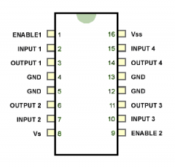

Fig 4.4: IC diagram of L293D

***4.2.5Gear motors:*** A "gear motor" may be an AC or DC motor coupled with a gearbox or transmission. A gear motor adds mechanical gears to alter the speed/torque of the motor for an application. Usually such an addition is to reduce speed and increase torque. A DC motor without gears is useful in many applications, for example the simple fan. Contrast that with the motor that operates the turntable in your microwave, a gearbox there reduces the speed so your food isn't thrown against the interior wall.

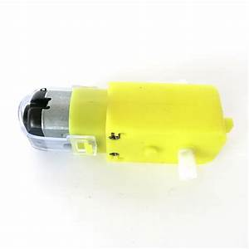

Fig 4.5: Gear motor

***4.2.6Servo motors:***A servomotor is a linear or rotary actuator that enables accurate control of angular or linear position, speed and speed. It comprises of an appropriate engine combined with a sensor for feedback from the position. It also needs a comparatively advanced controller, often a specialized module specifically intended for servomotor applications.

A servomotor is a closed-loop servomechanism that controls its movement and final position using position feedback. The input to its control is a signal representing the position ordered for the output shaft, either analog or digital.To provide position and velocity feedback, the engine is coupled with some sort of encoder. Only the location is evaluated in the easiest situation. The output's measured position is contrasted with the command position, the controller's internal input.If the location of the output differs from that required, an error signal will be produced which will cause the engine to rotate in either direction as necessary to carry the output shaft to the suitable position. The error signal decreases to zero as the positions approach and the engine stops.Most contemporary servomotors are intended and delivered from the same company around a dedicated controller module. In order to decrease costs for large-volume apps, controllers can also be created around microcontrollers.

We are using the MG966 servo motor in our project.MG966 is a metal Gear servo motor suitable for trucks, Boats, Racing Cars, Helicopters and Airplanes. The specifications of the motor is given below:

* Power Supply: Through External Adapter.
* Weight : 55g
* Operating Speed : 0.18sec / 60 degrees (4.7V no load)
* Operating Speed : 0.15sec / 60 degrees (6.1V no load)
* Stall Torque : 12 kg-cm (181.5 oz-in) at 4.7V
* Stall Torque : 14 kg-cm (209.3 oz-in) at 6.1V
* Operation Voltage : 4.7 - 7.1Volts
* Gear Type: Metal Gears
* Connector Wire: Heavy Duty, 11.80" (300mm)

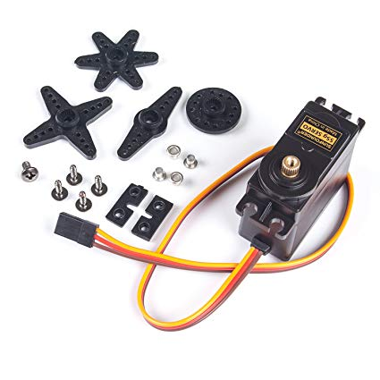

Fig 4.6: Servo motor

***4.2.7Robotic Chassis:*** This is the main equipment of our robotic vehichle.We will combine these parts to make up a moving robotic vehicle and also the base of the robotic arm which will pick and place things.

This Robotic kit consists of:

A wooden board for body

4 Gear Motors.

4 Compatible wheels

Screw and supportive parts set.

**DC motor specification:**

1. Rated Voltage: 3-12 V DC.
2. Unloaded speed: 120 RPM.
3. Load current: 190 mA (250 mA MAX)

**Wheel specification:**

1. Width:30mm
2. Diameter:65mm

***4.2.8Robotic Arm Kit:***

The robotic arm kit includes gear motors ,servo motors, a stand and arm gripper. These are the main components which we will combine to make our robotic arm which will be implemented to pick and place objects from one place to another.

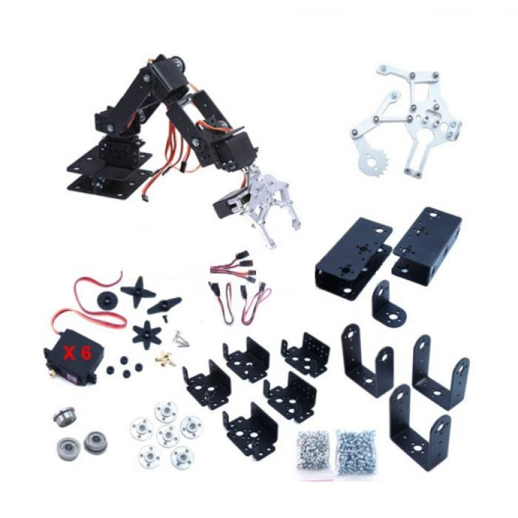

Fig 4.7: Robotic arm kit

***4.2.9Joystick controller:***

Beginning of our course, we decided to make a 6DOF robot arm which will be controlled by voice. But working on voice controlled Arduino project we have seen that to pick a object from a particular distance will not be so much efficient by voice as sometimes App doesn’t recognize the voice signal and arm may be go to the location where we don’t want. That’s why we want to control the arm by PS2 controller.

Although the Playstation 2 game console is now a somewhat obsolete piece of machinery, the Playstation 2 Controller Clones are still being produced and can be extraordinarily cheaply bought through trademe . Not only that, but connecting to an Arduino is simple. In relation to the two high-quality joysticks, all buttons are susceptible to pressure, adding to the device even more features.

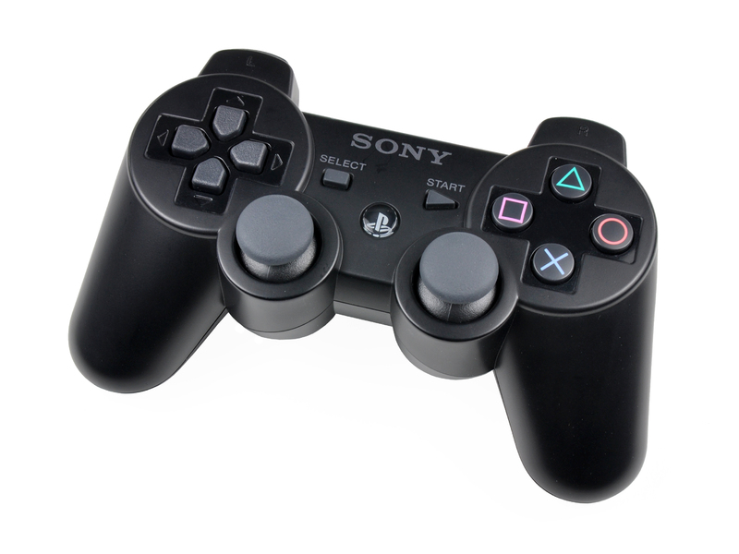

Fig 4.8 : PS2 controller

Sony game controllers have 12 pressure-sensitive analog keys (4 direction keys, 4 operation keys, Cross, Triangle, Circle, and Square, L1, L2, R1, and R2) and five digital keys (MODE, START, SELECT, R3, L3) and two analog joysticks. Inside controllers there are 2 engines that can vibrate due to their imbalance.

The wireless controller operates at a frequency of 2,4GHz and has a variety of 10 meters. It also has an optical send and receive information indicator. This controller only requires 3 AAA batteries for energy (only 2 AAA batteries are needed in some instances).

**Application of PS2 Controller:**

* Control of movement of a wheeled or tracked vehicle.
* The robotic arm control.
* Computer interaction.
* Pan and tilt camera mounting.
* DIY radio control scheme to convey commands from the Playstation 2 controller to another Arduino that controls the car using a bluetooth module or radio modul

**Connecting the Playstation 2 Controller to the Arduino:**

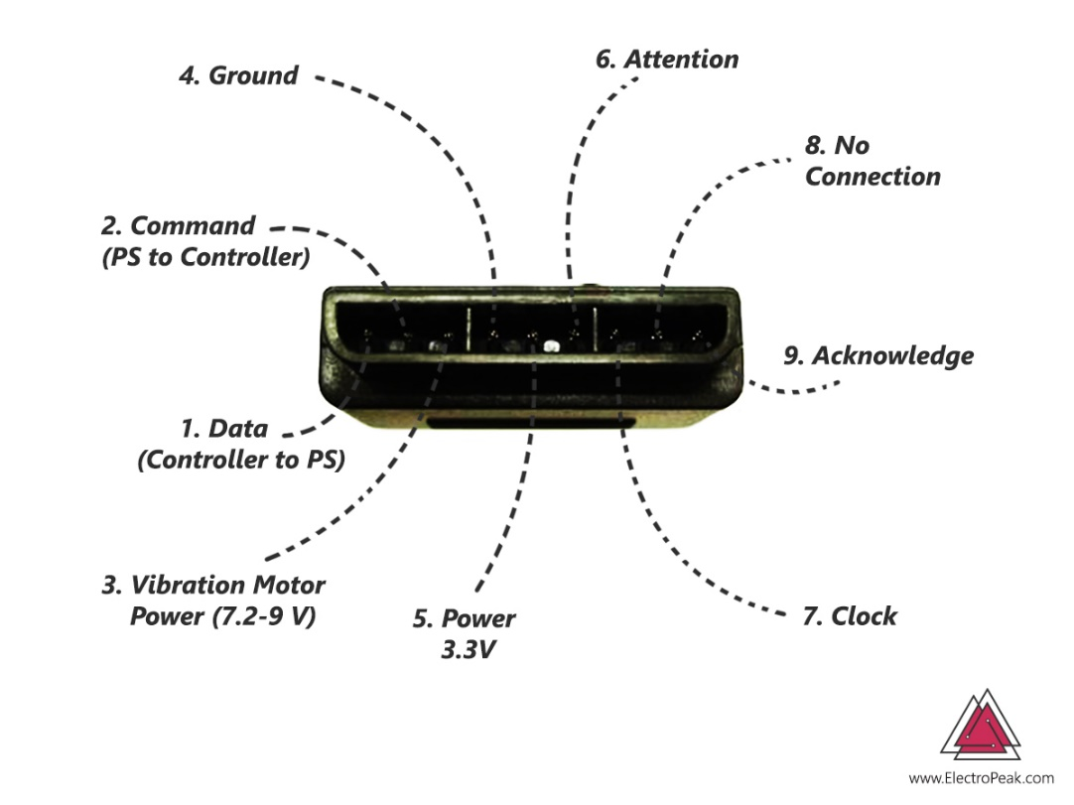

Fig 4.9 : PS2 controller receiver pins

* Data: master line for sending information to the slave (MOSI).
* Command: slave line for sending information to the master (MISO).
* Vibration: vibration motor supply: 7.2 volts to 9 volts Ground: circuits floor.
* VCC: circuits supply: 3.3 volts .
* Attention: CS or Chip Select pin for calling the slave and preparing the link.
* Clock: equal to SCK pin for button.
* No Connection: unnecessary.
* Acknowledgement: acknowledgement signal from the clock.

*Connection between ps2 controller to Arduino :*

Data-------------> Arduino digital pin 12

Clock------------> Arduino digital pin 13

Attention--------> Arduino digital pin 10

Command------> Arduino digital pin 11

If we want to work with PS2 controller with Arduino microcontroller then we have to include PS2 library to the Arduino. We can open the PS2X library example or driver code and upload it to our board after adding the library to Arduino. We can see the outcomes by pressing distinct buttons in the serial monitor window.

***4.2.10 PCA9685 16 Channel Module:***

In our project we are using six servo motors to build robotic arm. The movement of the motors will be based on pulse width modulation and pulse length. The Arduino function we are using that doesn’t work if we connect the servos directly with the PWM pins of Arduino Mega. That’s why we are using servo driver PCA9685 16 channel Module.

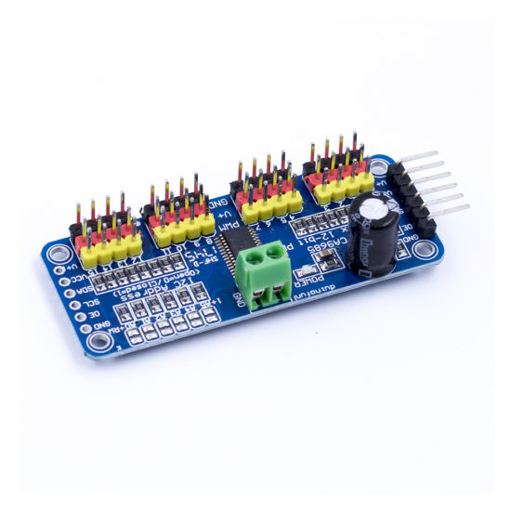

Fig 4.10 :PCA9685 Channel Module

The PCA9685 is a 16-channel I2C-bus LED controller optimized for color backlighting apps for Red / Green / Blue / Amber (RGBA). Each LED output has a set frequency PWM controller with an individual 12-bit resolution (4096 steps).It’s a PWM driver with an i2c-controlled built in clock and Adjustable frequency PWM up to about 1.6 KHz.It complies with 5V, which implies that you can regulate it from a 3.3V microcontroller and drive up to 6V inputs securely.

Frequency setting should be between 40-1600 Hz. But the frequency varies based on output. If the output is LED then the frequency setting should be 1000-1200 Hz and if the output is servo motor then the the frequency will be 40-60 Hz. As our output is servo motor so we must set out frequency 40-60 Hz.

The following code will set the PWM frequency to 60 Hz :

pwm.setPWMFreq(60,SERVO);

Connection between Arduino Mega to Servo Driver:

|  |  |
| --- | --- |
| Arduino Mega | Servo Driver |
| 5v | Vcc |
| GND | GND |
| 20 | SDA |
| 21 | SCL |

Table: Arduino to Servo motor connection

If anyone use Arduino Uno then the connection of SDA, SCL to Arduino Uno will be 4 and 5 number pins of Arduino. These pins are analog . We can connect 16 servo motor with a PCA 9685 servo driver we can connect more than 100 servo with a single Arduino code by connecting several servo driver. In our project we need six servo motor. At first we will connect the SDA,SCL pin to the pin of Arduino that we stated then we will connect six servos to the pin one to six of the servo driver.

## *4.2.11 DC-DC Boost Converter (XL-6009):*A boost converter (step-up converter) is a DC-to-DC power converter that increases voltage from input to output while stepping down current. It is a class of switched-mode power supply that contains at least two semiconductors (a diode and a transistor) and at least one energy storage element: a condenser, an inductor, or the two together. To decrease the ripple voltage. Filters produced from condensers (sometimes in conjunction with inductors) are usually added to the output (load-side filter) and input (supply-side filter) of such a converter to decrease voltage ripple.

To power PCA 9685 16 channel module we have to power 5-6v. Normally in market 3.7v li-ion battery , 9V dc battery. We can use four 1.5v li-ion battery but sometimes 1.5v li-ion battery is less available. So we decided to use 3.7v to power the servo driver by boosting up the voltage by boost converter. We can use XL-6009 dc-dc boost converter to power the servo driver.

XL-6009 module is a non-insulated step-up (boost) voltage converter with high efficiency and adjustable output voltage.A 3-digit 7 segment display is provided for the module. So the voltage can be readily seen and monitored. It is necessary to adjust the output voltage by tuning the POT variable. It’s input voltage rating is 3-32V and gives output voltage 5-32V and maximum current rating is 4A. Boost converter step up voltage and step down current. So, when we will be working on the device which have more power rating like 30W LED light. Then the current requirement of this is high and input current is so high. So, for our safety we have to care about wire length. The diameter of the input or supply side will be higher than the output side, the ratio will come from the calculation. In our project we should also care about this but this isn’t mandatory because the driving current of servo motors are 400-700 mA so this will not cause problem.

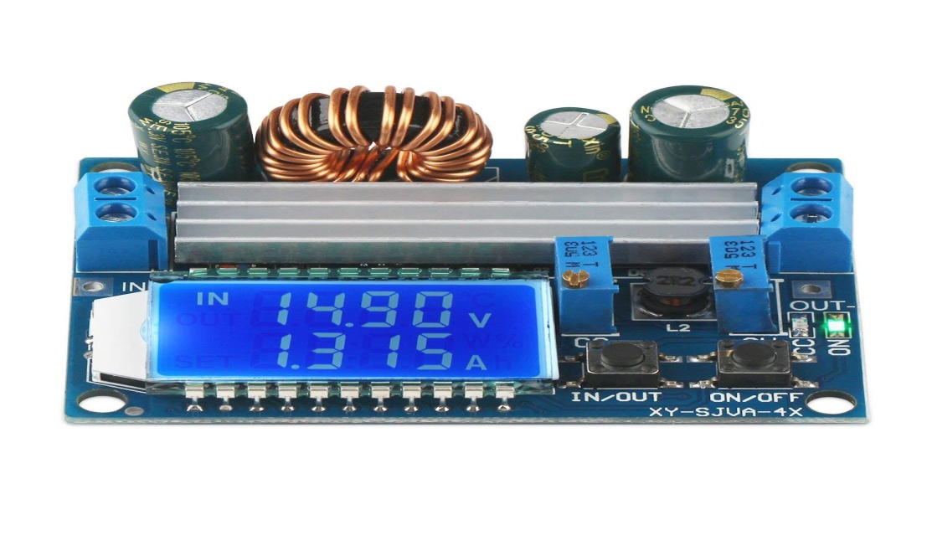

Fig 4.11 : DC-DC boost converter (XL-6009)

***Battery:***We have used two kinds of battery.One is the nine volt battery and the other is the lithium ion battery.(9V battery is used to power up the Arduino uno and the robotic vehicle and the li-ion battery is used to power the Arduino mega and the robotic arm gripper).

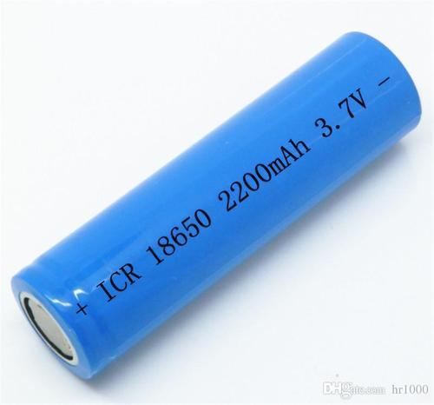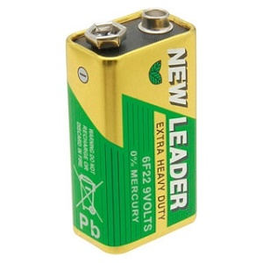

Fig 4.12: Li-ion battery(left) & 9v battery(right)

**Wires:**

Wire is also very important element of this to connect with the equipment and power supply. In our Circuit we use different types of wire to connect different things. Different wire has different capacity and we used normal wires and jumper wires to connect Arduino , sensors and other devices.

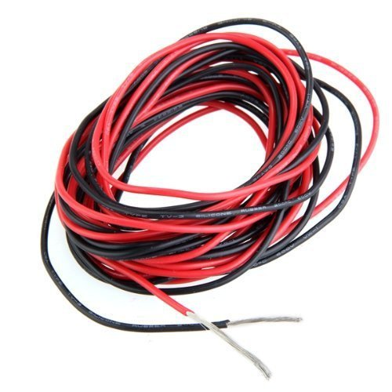

Fig 4.13: Wires

## 4.3 Summary

In this chapter, we have discussed the components, their features and how they have played vital roles respectively to make the project a perfect one. We have discussed every single component and their reasons for using. We have used reasonable components and that is the most interesting part of the project.

**DESIGN IMPLEMENTATION**

**5.1 Introduction**

We will address the design of the project's technical features in this section. Implementation is the action that must follow any preliminary thinking to actually accomplish something. In order to operate in harmony with other characteristics, our project characteristics require ideal design execution. In this portion, we addressed the entire execution of the design.

## 5.2 List of necessary hardware components

* Arduino Uno
* Arduino Mega
* Bluetooth HC-05
* L293D IC
* Battery 9v
* Breadboard
* Android phone
* Jumper wires
* Robotic chassis
* Servo motor
* Gear Motor
* Robotic arm kit
* Lithium Ion Battery
* PS2 controller
* PCA9685 Channel Module
* DC-DC Boost Converter

## 5.3 Description of operation

As mentioned before our project consists of two parts. One is the robotic vehicle part and the other one is the robotic arm part.

We will discuss about the design implementation of these parts below:

**5.3.1 Robotic vehicle:**

The Robotic vehicle is controlled through voice commands given by the user who is operating the project. These voice command needs to be given through an android app which is installed on the user’s android mobile. Please note that user should have good internet connection in order to have a smooth operation of the android application.Speech recognition is performed within the Android app and a command is then sent to the robotic car controlled by the voice. The Arduino Uno installed for the controlling of the robotic vehicle decodes these commands and gives the motors connected for the movement of the vehicle a suitable command.

The movement of the robotic vehicle is controlled by voice control. This portion is based on android. We used Bluetooth device in this portion to obtain user command. User use android application to command Bluetooth device. Bluetooth device receives an application command and transmits the same to Arduino Uno, then it regulates the robotic car as per command. Arduino Uno is the main unit of this part. It’s the central processing unit (CPU) of the Robotic vehicle. It receives various commands from BLUETOOTH moduleand gives the respective output to motor driver IC.

In this portion, the mobile device that connects to the Bluetooth module connected to the arduino controls the robotic car. So we need 1 Bluetooth module and 1 android mobile. Bluetooth module is always connected to the arduino and the Robot's movements are controlled by another mobile phone.The Bluetooth module provides the output of the ASCII code. This receiver allows serial information to be transmitted wirelessly and received. It has a range of 10 meters. For robotic vehicle motion, DC motors and adequately powerful four wheels are used.

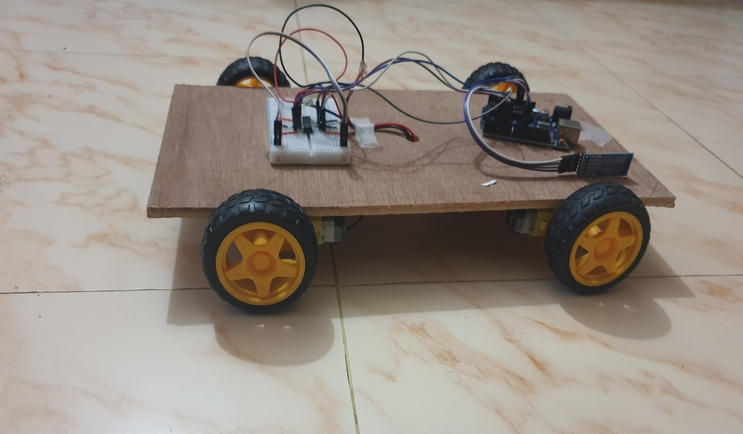

Fig 5.1:Robotic vehicle(Voice controlled)

**5.3.1 Robotic Arm:**

A ps2 controller is used to control the robotic arm to move and pick things. The joystick is connected with the Arduino mega via control receiver. The ps2 controller will control the movement of the arm so that it can easily be used for picking and placing objects. The joystick controller is wireless and portable.

When we will press a key of the joystick it will send a command to the Arduino mega and the Arduino mega will pass the message to the linked servo motors which are connected with the Arduino mega. Each key of the joystick controller has different function to do. There are 5-6 servo motors in the robotic arm that’s the reason of using the Arduino mega as there are more input pins. The joystick is wireless so that the robotic arm can be controlled from a bit of distance.

This robotic arm looks intimately like a human arm- it has a shoulder, an elbow, and a wrist equivalent. The shoulder is typically installed on a stationary foundation rather than on a mobile body. This has six degrees of liberty, which means it can rotate in six ways. By contrast, a human arm has seven degrees of liberty. The robotic arm is strong enough to lift up to a minimum of 2-3 kg. The fixation of the robotic arm to the moving base has been done by certain amount of screws and nuts so that it remains in that manner for a longer period of time and it has a longer sustainability for at least a few years.

**5.4 Principle of operation:**

Firstly there are two control systems in our project. One is voice and the other is joystick. We will use voice to control robotic vehicle and joystick to control the robotic arm. The robotic arm will pick and place objects from one place to another and thus its course of work will come to an end.A flow chart of the principle of operation of our project is given below:

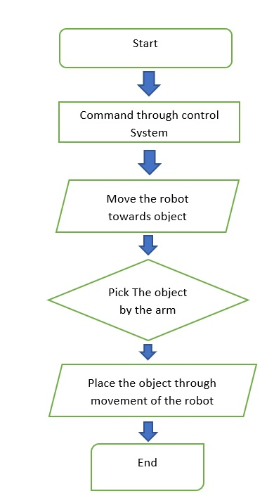

Fig 5.2 : Principle of operation

**5.5 Summary**

So we discussed about the components required and the principle of operation in this chapter.We can have a clear view of our project from this chapter.

**TECHNICAL DETAILS**

**6.1 Introduction:**

In this section we will address how we have implemented our project and how distinct links have been established that have led in our final prototype that we are about to present. We're also going to talk about how we analyzed our project to improve it.

**6.2 Technical Details**

As stated above, there are two parts of our project. These two parts’ implementation will be clarified here. How each of the components was applied and how we paired these two components and made it one will be addressed in this portion.

**6.2.1 Implementation of robotic vehicle**

In order to make a perfectly functional moving robotic vehicle we have to use a good motor that can carry the vehicle.We used 4 gear motors for this.Firstly we shorted the two motors of each side so that it can be easy to program a code for the motors.Then we used glue gun to attach the motors in the robotic chassis.As there is also a robotic arm in our project we had to think about a strong base.We used a lightweight hardboard for it.This hardboard is both strong and lightweight.It is easy for the wheels we used to carry the full weight of our project.Then the motors were connected to the L293D IC which is connected in a mini breadboard above the chassis.Then the outputs of the motor driver IC are connected with the Arduino inputs in following ways:

L293D ------------------------------------------------->Arduino:  
 pin 2 (for left motor: pins 3 and 6) -----------------> pin 5  
 pin 7 (for left motor: pins 3 and 6) -----------------> pin 4  
 pin 10 (for right motor: pins 11 and 14) -----------> pin 6  
 pin 15 (for right motor: pins 11 and 14) ----------- >pin 3

Then the Bluetooth module HC-05 is linked straight to the Arduino Uno to prevent any system mistake in the bread board. In this manner the Bluetooth module has the smallest opportunity of being damaged or frequently disconnected from the Android app.The HC-05 module has been connected to the Arduino in following order:

|  |  |
| --- | --- |
| HC-05 | Arduino Uno |
| Rx | 11 |
| Tx | 10 |
| GND | GND( Common ground) |
| +5v | Vcc ( both given to common power supply) |

Now we uploaded the code to the Arduino Uno and made it ready to deploy.Now comes the most important issue which is the power supply.For the smooth running of the four motors we shorted to 9v batteries together so that the motors get enough power and have a certain speed to move.And another 9v battery is connected with the Arduino.This battery gives power to both the Arduino Uno and the Bluetooth module.After connecting the battery the robotic vehicle is ready to go.

An android app “**Voice Bot**”has been used in this project. The HC-05 is a perfect module which can add two-way (full-duplex) wireless functionality to our project. We can use this module to easily communicate between two microcontrollers like Arduino or communicate with any device with Bluetooth functionality like a Phone or Laptop. There are many android applications that are already available which makes this process a lot easier. The module communicates with the help of USART at 9600 baud rate hence it is easy to interface with any microcontroller such as Arduino that supports USART. We can also configure the default values of the module by using command mode. So looking for a Wireless module that could transfer data from computer or mobile phone to microcontroller or vice versa. So this module might be the right choice for us.Here is the circuit diagram of our project. It is simulated by “Fritzing” software.

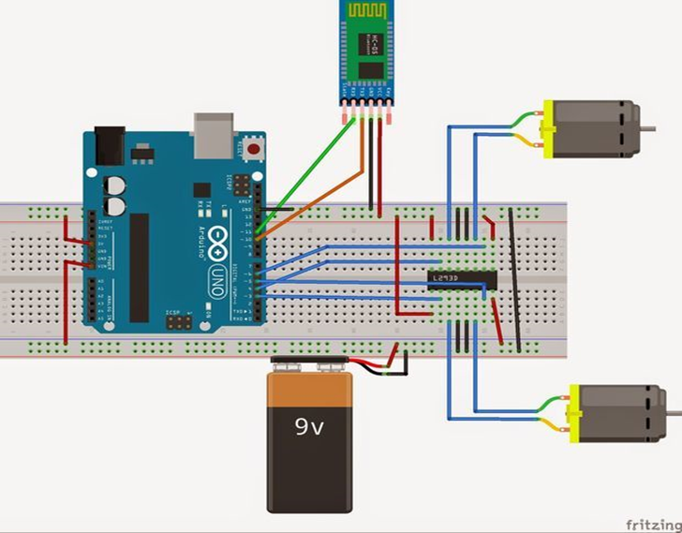

Figure 6.1:Circuit diagram(Robotic vehicle)

Now as the robotic vehicle is ready we will move towards our next part which is the robotic arm. We will attach it in the same chassis. So that the project remains handy, portable and very easy to use. The summary of the implementation of this part can be explained as follows:

* Connecting the HC-05 Bluetooth module with smartphone.
* Giving a voice command using the app through smartphone.
* After receiving the command, HC-05 Bluetooth will pass it to the Arduino.
* Based on the command, Arduino will command the required L293D motor driver IC which will further actuate the wheel.

**6.2.2 Implementation of robotic arm**

A robot arm has a mechanical framework that changes its shape using a group of electrical engines that act as servo motors, pneumatic actuators or hydraulic actuators. They try to replicate a human arm-like motion.There are several considerations that need to be considered when building a robotic arm, including the maximum load weight, the torques of each of the servos, how much weight each servo has to sustain in relation to their place in the arm, and the weight of each frame that constitutes the arm.

We must first download and install the Adafruit PWM Servo Driver Library, PS2 Arduino Library, before implementing our robotic arm. Then we need to save these to the local folder of Arduino IDE libraries. We need to go to the Sketch tab to install the libraries open on Arduino IDE, then select Include Library-> Add. Zip Library. To be included in IDE, we need to pick the above libraries. Before we can control our Robotic arm with the PS2 Controller we have to check the following steps:

* Switch to the PS2 Controller and check that the LED mode is illuminated. If it doesn't, we need to press our controller's Mode button.
* After doing the above, we need to press the reset button on your Arduino Mega for it to read our controller settings.
* Then we have to check whether the controller is working correctly or not for that we have to Open Arduino IDE .Then selecting this path Files>Examples> PS2_Arduino_Library, Select PS2X_Servo. Then we will upload the PS2 driver code to Arduino Mega after that we will press the keyword of the controller and we have to notice the serial monitor. If we

find error then we have to fix the bugs.

Then we will connect the PS2 receiver to Arduino Mega. The connection between two is below:

|  |  |
| --- | --- |
| Arduino Mega | PS2 RECEIVER |
| 5v | GND |
| 3v3 | VCC |
| 13 | DAT |
| 12 | CLK |
| 11 | CMD |
| 10 | CS |

Our robotic arm’s degree of freedom is six. So there are five joints. While doing senior design 01 (EEE499A) we decided that we would use inverse kinematics in our coding. Our target was to finding the DH parameter and then finding the joint angle by the jaccobean method or simple Pythagoras theory. These procedure was good enough where the arm’s end effector (position of the gripper) was known and it move to the position based on user’s command. We think this system is not efficient because when we need to pick a object from a certain point we don’t know the coordinate axis of the position from a reference point. So we decided not to use this. We will implement our project by the help of pulselen( ),pwm.setPWM( ) functions.

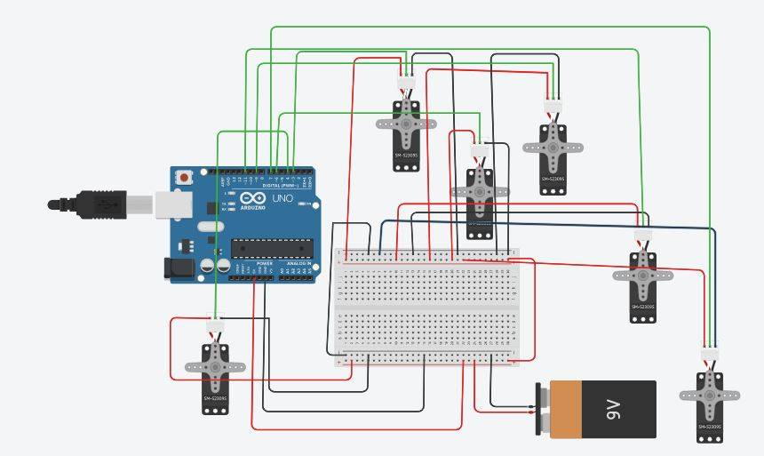

Fig 6.2: Circuit Diagram of Robot Arm

Our next task is to connect the five servos (MG-996) with Arduino Mega PWM pin . Pin 2-13 plus 45 and 46 work fine for PWM, but 44 behaves like a digital-only pin, turning only on or off when using analogWrite(). Arduino Uno has six PWM pins whereas two pin are used for connecting PS2 receiver that’s why we used Arduino Mega. But we can use Arduino Uno connecting with 16 Channel 12-bit PWM/Servo Driver. In simulation we use Arduino Uno and connect the servos to the PWM pin . We did simulation in tinkercad ([www.tinkercad.com](http://www.tinkercad.com)) website where Arduino Mega is not available that’s why we used Arduino Uno.

Several buttons are used to control the base, elbow, shoulder, wrist and claw . Here are the control of the arm’s parts which will be done by the help of the joystick controller:

|  |  |  |
| --- | --- | --- |
| Button | Control | Action |
| L1 | Claw | Turn Left |
| L2 | Claw | Open |
| R1 | Claw | Turn Right |
| R2 | Claw | Close |
| ARROW UP | Shoulder | Move Up |
| ARROW DOWN | Shoulder | Move Down |
| ARROW LEFT | Base | Turn Left |
| ARROW RIGHT | Base | Turn Right |
| TRIANGLE | Elbow | Move Up |
| SQUARE | Wrist | Move Up |
| CIRCLE | Wrist | Move Down |
| CROSS | Elbow | Move Down |
| JOYSTICK UP | Speed | Control Speed |

Table: Control of the servo motors

## 6.3 Skills required

Some abilities that need to be acquired are compulsory to execute the project properly. The skills required to execute the work of the project are discussed below:

**1. Basic electronics /electrical knowledge**

The first thing required was the fundamental knowledge and abilities of electrical / electronics to comprehend circuit diagrams, parts such as resistors, condensers, diodes, ICs, transformers, motors, etc. Usually these projects come with lots of parts and we need to assemble them. To connect the engines, ICs and other electrical elements, this skill is a must.

**2. Basic programming skills**

Secondly as we are working with Arduino Board, then we need to know to write programs with the Arduino Compiler. We will be using C++ codes for both of the Arduino so we needed basic skills and knowledge about this programming language.

**3. App inventor Concept**

This is another important skill which helped us to learn how to build an app in android system. Also this gave us the idea how to sync the app with our hardware device. We built an app called “The Voice bot” using this concept.

**4.Configuration of the microcontrollers and IC’s**

The way how the microcontroller and IC’s work in the real circuit is also listed as a skill required to complete this project. Without this knowledge we couldn’t have connected the wires properly to the Arduino’s pins.

**5.Arduino simulation tool**

As we simulated the project before working on it so we needed the knowledge of simulating tool. So we learnt it and simulate our circuit using the Tinkercad website and found out whether the servo motors works properly or not.

**6.4 Conclusion**

In this chapter we broadly described the process of implementing our project and the process of constructing the prototype in detailed manner. Anyone can build the project by going through this chapter. We also discussed about what knowledges are required to do the project.

**RESULT ANALYSIS**

**7.1 Introduction**

We will discuss the outcomes we have acquired and their evaluation in this chapter. This demonstrates how we got our outcomes and what our project findings were. We will also discuss the difficulties faced during the first deployment of our project. We're also going to talk about how we analysed our project to improve it.

**7.2 Results and Analysis**

After separately analysing our system, we saw that the project works perfectly. Which implies, we introduced the prototype of the whole scheme efficiently, which we originally planned. Both of our microcontrollers are working properly along with the L293D IC and the Bluetooth module. When we gave voice instructions to the robotic vehicle using the mobile phone and it performed the commands perfectly. The joystick controller was also used to move the robotic arm and pick and place stuff. As per the specified command, it was able to manage the robotic arm effectively. The batteries provide enough energy for all the motors with which we worked with.

We also checked the variety of the Bluetooth voice control system and discovered that it has a range of at least 10 meters as anticipated. In addition, the wireless joystick control system, there is also a satisfactoryrange. Up to 2-3 pounds can be carried by our prototype. So, we can say that it was a successful implementation of our project.

Here some of the things we figured out during making this project:

1. Takes 2-2.5 second for implementing command which is given by Android App.
2. Maximum distance range covered by this robot is approximately 10 Meters (30 feet).
3. The speech recognizer is tested to prove its performance to generate exact movement of the robot, recognition rate is above 90%. This percentage might reach 100% if the test is done in clear environment with good pronunciation of words with moderate time.
4. The joystick controller can move the robotic arm to pick and place from one place to another precisely. The accuracy for this part is almost 100%.

**7.3 Difficulties Faced& Solutions**

During the execution of our project, we experienced some problems. This made us to think andwork about changing our project. We attempted our utmost to meet these issues and properly solved them, which made our project better and more effective. Some of the problems we encountered and resolved later are discussed below:

* Firstly, we decided to regulate the entire project by using voice, which implies both the robotic car and the robotic arm portion. We saw later that it was less effective. But since we wished to work with voice control, we kept the voice regulated by the robotic vehicle, but the better part that is the robotic arm is now programmed to be controlled by joystick control.
* Secondly, the coding of the robotic arm was difficult because we had to be conscious of a lot of stuff like free motion, claw and six joints as well. We wanted to do the coding at the beginning with the help of inverse kinematics but it's a bit complex and difficult to achieve the expected control. It's also hard to accomplish the angles. So we investigated more and discovered an alternative way for the control of the arm that also works similarly.
* It was a difficult job to select the Android app to convey voice control to the motor driver IC. To find out an app that will function perfectly, we had to research a lot about it. Lastly, we found the "Voice Bot" app. It was consistent and worked well with our code.
* The selection of batteries was also our major issue. We simulated our project circuit with various batteries. After a lot of discussion we finallydecided that we will our power up the robotic vehicle with three 9v batteries and the robotic arm part will be powered with the help of lithium ion batteries.These batteries give enough power to all the motors we are using in this project.
* Lastly, the selection of the robotic chassis was a tiny problem. We had to remember that the chassis had to be large enough to allow the robotic arm to be inserted into it and at least be able to carry a minimum weight that the robotic arm would pick and place from one place to another. As we did not find anything like that in the market, we decided to use a strong lightweight hardboard by measuring it as per requirement.

**7.4 Conclusion**

We addressed the outcome and evaluation of our project in this section. This section discusses the findings achieved and we believe that our technique has enhanced the whole system. We also addressed how the issues we encountered were solved and how we made our project function correctly and delivered ideal production better than we anticipated. The voice controlling commands are successfully transmitted via Bluetooth technology and on reception; the desired operations successfully take place. Such systems can be brought into use at places such as industries, military and defense, research purposes, etc.

**RISK FACTOR, APPLICATION, ADVANTAGE & DISADVANTAGE**

**8.1 Introduction**

While implementing a project some facts are always kept in mind. These facts describe the quality of any project. In this chapter we are going to discuss about risk factors, advantages, applications & limitations of our project.

## 8.2 Risk Factors

1. **Achieving accuracy in motion control**:

A robotic arm may have 2-6 engines, each controlling members with different quantities of inertia, which are also not all of the same size or shape. These are either direct-control stepper motors (for low price, size, precision choices) or servo motors, regulated by feedback loops from encoders that measure their position and/or speed.The greatest difficulties are the precision of achieving the desired position at the end of the trajectory and also the repeatability of placement (receiving next cycle at the same stage). This must be delivered by the chosen machinery and the noise-creating variables (oscillations, nonlinear friction, electromagnetic interference) must be resolved.

1. **Optimizing the trajectories** :

The system must have inertial forces, least starting time , motion envelope and collision control. A project having these things are meant to be considered a good project.

1. **Power concern**:

Another risk factor is power to weight ratio of actuators (ie. strength of the motors) and Energy density of power storage devices (ie. battery life).

1. **Weight and size**:

The main mechanical challenge is related to the weight and the size of the parts of the arm, while achieving accuracy and strength meeting or exceeding that of the natural limp.

1. **Carrying ability of the vehicle**:

It is also a great concern that if the weight of the robotic arm is much , then it will be tough for the vehicle to carry that and high weight can decrease the speed of the motor which eventually decreases the efficiency.

1. **Functional challenges**:

Some of the biggest challenges is making it functional. Over the years different approaches have been tried, from connecting sensors on skin, to inserting needles in ruptured veins. Some have use alternate limbs to control arms too (using mouth or feet to control prosthetic arm).

1. **Control system**:

Many robots has so much overshooting, high rise time, unstable peak value. To make them stable we need to apply closed loop feedback control system. Based on the system we decide which controller can be used( ie. pi,pd,pid controller).

## 8.3 Solutions:

The solutions for the risk factors are given below:

**1.Voice controlling problem:**

Sometimes the apps used to deliver voice command to the robot does not work properly and also don’t take command properly.We should be careful about that so that our robot can take commands properly and work accordingly to it.

**2.Free movement of the arm:**

The free movement of the arm is very difficult to achieve.For this we had to study forward and inverse kinematics so that the arm can move freely in six axis that we intend to build.

**3. Capability:**

The capability of the arm and also the capacity is a question.The base of the arm must be very strong so that it can carry the certain amount of weight it will be given to carry. Also the robotic hand must have the capacity to pick and place a certain amount of weight.

**4. Power source:**

As our project deals with six to eight servo motors, four gear motors the power source to be given remains a concern.We have been looking into it and as per our study a 12 v li-po battery may come into work.

**5.Rotational Matrix:**

To implement equations of the joint angle, we need to find the roational matrix rotating x,y,z axis. We can find these equations from the help of robotics book but the servo motor may not work according to the equations or matrix which we derived, we need to solve it.

**6.Robotic Arm control:**

Controlling the robotic arm is an important issue. To solve this problem once and for all and control the robotic arm precisely we used a ps2 joystick controller and programmed it in such a manner that it can easily complete its job.

**8.4 Applications:**

A pick and place robot has many applications.These kinds of robots are becoming very common throughout the globe for daysnow.Some of these robot’s applications are described below:

* **Fruit picking:** For a fruit gardener, it is extremely important to harvest fruit in time. In a large garden there is need of many people to select which fruit is ripen enough to pick out. We can use our project to help the gardener. It will be time consuming process and if not done in time would cause wastage and money loss. Our primary idea is to just fruit picking by gripper and send it another place. And if we can do the part in time then we will create a system which will only pick the fruits if the fruit is ripen enough by image processing.
* **Helping physically disabled people:** Robots can really help people with disabilities in a number of different ways. High-speed pick and place robots take product from one location to another with pinpoint accuracy. Physically disable people benefited greatly by this application of robot. This robot can provide increased efficiency as well as decreased production costs and ergonomic issues.
* **Manufacturing process:** Now-a-days robots/robotic hand grippers are playing a major role in manufacturing company. As robots do not suffer fatigue from performing repetitive tasks, they are also an ideal solution for primary packaging tasks .Depending on the item being handled and the automation requirement of the manufacturer, pick and place robots are used in many aspects. There are four primary methods to use robots in the manufacturing process they are as follows:
  1. **Assembly:** Pick and place robots, pick up an incoming portion from a conveyor belt during assembly procedures and then place it on another piece of job, which is typically carried away by another conveyor belt.
  2. **Packaging:**A pick and place robot takes a part on an incoming conveyor belt, comparable to installation procedures, and instead of assembling the portion, the robot places it at a high velocity in a packaging container.
  3. **Bin Picking:**Pick-and-place robots fitted with sophisticated vision technologies can grab a portion of a bin, sometimes even when components are randomly blended together in a bin, and place this portion for manufacturing on a conveyor.
  4. **Inspection:**Vision devices can monitor products moving on an incoming conveyor belt and identify defective products, and then a robot can remove the defective product before it reaches the final manufacturing stages.
* **Medical Applications:** These kinds of robots can be developed and used in multiple activities such as joint replacement, orthopaedic and internal surgery. It conducts the procedure more accurately and with greater precision.
* **Defence applications:** These robots are becoming very popular now a days in defence systems. Many first world powerful countries have already introduced robots in defence systems. It can be used for surveillance 24x7, as there is no question of tiredness. Moreover it can also pick up harmful objects like bombs and defuse them safely.
* **Oil refineries and mines:** Accidents such as landslides happen more frequently in oil refineries and mines, resulting in the death of many employees. Adequate coals can also sometimes not be mined during carbon mining, maintaining workers ' security and health problems as well. It is possible to use pick and lace robots here to get better and faster manufacturing.
* **Hazardous Environments:**Robots in hazardous environments assist prevent accidents that may pose a serious life danger to the operator, co-worker, machinery, and environment. Some procedures can be produced quicker, more reliable and more secure with the assistance of robots. In other words, robots help generate a safe working atmosphere with less danger and thus contribute to better outcomes.
* **Space Exploration:**We can send these types of robots to explore space without having to worry about their safety. It is also much cheaper to send a robot to space than to send a person. There's no need for robots to eat, sleep or go to the bathroom. They can survive in space for many years and can be left out there — no need for a return trip!Plus, robots can do many things human beings can't do. Some may resist severe circumstances, such as extreme temperatures or elevated radiation concentrations. Also, robots can be constructed to do stuff that astronauts would find too risky or impossible.

**8.5 Advantages :**

As mentioned above, we see many of our project's applications. Now we'll mention the benefits we'll have if we can use these pick-and-place robots in different working areas. The benefits are outlined below:

* One of the most sound statements to be made in the case of industrial robots is cost-effectiveness. By eliminating inner expenses to compensate for human wages, robots will decrease manufacturing expenses. Businesses predict that their profitability will increase once robots are put into manufacturing or that they will have greater economic mobility to invest in fresh products or techniques.
* The use of equipment in manufacturing is anticipated to provide quality assurance. With mass production of produced products, industrial robots will be able to guarantee consistency. The potential human error posed by assembly line employees poses the risk of being removed.
* Optimized effectiveness in manufacturing implies that a general manager can set the quantity and quality standards that robots will meet. Low concentration, break time and accidents to employees, among other things, will not jeopardize production quotas.Robots will increase the effectiveness of manufacturing forecasts and supply levels, enabling programming to operate at the optimum pace for a specified plant.
* Limiting human job in dangerous settings as manufacturing jobs often place employees at greater physical danger than many other sectors. Lowering the amount of risk presented to staff on the job is appealing to managers in order to maintain the reputation of the business and minimize future legal obligations.Riskier sectors such as manufacturing and mining, which have notorious disasters such as the Upper Big Branch Mine, look to robots for their capacity to replace unqualified employees in dangerous settings doing the needed employment.
* Another advantage of using these kinds of robots in industrial use is reliability. These robots can work 24x7 for 365 days without tiring or stopping if they are being programmed inthat way.
* Universal pick and place robots can be readily deployed in tight space circumstances in applications due to their tiny size and lightweight robot construction.
* Easy programming and a quick average set-up time make Universal Robotic arm ideal even for small-volume production where it would not be cost-effective to rearrange large-scale installations.
* It's quick and simple to move the pick-and-place robot to fresh procedures, offering you the agility to automate almost any manual job, including those with tiny batches or quick changes. The robot can reuse programs for recurring duties.
* These types of robots can easily lift heavy things from one place to another which is sometimes difficult for humans to do.
* Pick and place robots in today's installations have become a common robotic application. These robots provide producers with demonstrated benefits and alleviate employees from monotonous, repetitive job.
* It is very cost effective due to the advancement in technology. So it can be installed and used very easily for automation applications.

**8.6 Disadvantages:**

There are two sides of a coin according to the law of nature. There are also some disadvantages, despite having so many benefits. As we work for society's welfare, we will also mention them. The drawbacks of pick-and-place robots of this sort are provided below:

* Job loss is by far the most important resistance to the manufacturing industry's use of robots. Industry employees at all levels, from entry-level to veterans, are concerned about their job security status and the capacity to replace their work with a robot.This panic in this sector is more common than in others because of the closer immanence of a manufacturing robot takeover.
* Macro impacts are another subject that generally leads to work losses. More "large image" thinkers wonder how, when production workers ' jobs are displaced, the domestic and eventually global economy will be influenced. How can this mass unemployment be compensated and how can the supposed achievement of the robots be restricted by infiltration into other sectors?The world media provided an extremely poignant parallel, stating that what human employees are to robots is horses to vehicles.
* Increased investment costsare a financial counterpoint to industrial robots, with the idea that manufacturing companies will rack up their debt investing in robotic technology. Firms that do not have the funding might even go bankrupt in an effort to keep up with industry trends rather than continue on with normalized operations.In addition, staff will need training and communicate with the latest robotic machinery. This usually requires time and economic performance.
* Eliminating a whole working class would probably happen a bit of a way down the street, but the consequences of this point are too big not to be taken into consideration. The introduction of robots to take unqualified employment will put more stress on the economy, education system, and financial market, just to name a few.
* Although robots may safeguard employees from certain risks, their very existence may generate other safety issues in the meantime. These fresh risks need to be taken into account.

**8.7 Conclusion:**

In this chapter we have discussed the risk factors, solutions, advantages and disadvantages of our project which is the pick and place robots. In spite of having a few disadvantages we can say that these types of robots are very beneficial in industrial places. So we can conclude that this types of robotic systems are necessary for a developing country like us for better production.

**WORK STRUCTURE**

**9.1 Introduction**

In this chapter, we observe the entire work structure, meaning how the scheduling was maintained throughout the developmental phase. We shall also see the financial foundation of this project and furthermore the feasibility study should be also discussed.

**9.2 Work Breakdown structure:**

In order to develop this system, we gave ample importance to scheduling because we believed if we want to provide the best of quality then we must give due importance to scheduling which helped us to garner better results. The figure below focuses the weekly work we had accomplished.

|  |  |  |  |  |  |  |  |  |  |
| --- | --- | --- | --- | --- | --- | --- | --- | --- | --- |
| **Task** |  |  |  |  |  |  |  |  |  |
| **Project Topic Selection** |  | - | - | - | - | - | - | - | - |
| **Project Proposal Presentation** | - |  |  |  | - | - | - | - | - |
| **Research on project** |  |  |  |  |  |  |  |  |  |
| **Paperwork of the project** |  |  |  |  |  |  |  |  |  |
| **Component’s Collection & Briefing** | - | - | - | - |  | - | - | - | - |
| **Wiring Implementation on Circuit** | - | - | - | - |  |  | - | - | - |
| **Code Build & Test** | - | - | - | - | - | - |  | - | - |
| **Bug Fixing & Final Test** | - | - | - | - | - | - | - |  | - |
| **Final Demonstrations** | - | - | - | - | - | - | - | - |  |

**Table : Work plan**

**9.3 Cost of Implementation**

The parts used, their prices and the methods engaged in the proper functioning of the scheme are important considerations in the development of a project. We first mentioned the stuff that were originally required when we planned our scheme, and as time passed we added more parts to it.We initially produced a costing list with the name of the parts, but later we were able to cut costs from our original costing compared to various stores where our parts were accessible.

Here is our complete price for the project to be implemented. We attempted our utmost to minimize the price as much as we could. We are successful in implementing our planned system at a limited cost, adding great value to the system. Table 9.1 illustrates the name, quantity, and price of the required components.

|  |  |  |
| --- | --- | --- |
| Component name | Quantity | Price (Bdt) |
| Arduino Uno | 01 | 405 |
| Arduino Mega | 01 | 770 |
| Gear Motors | 04 | 580 |
| HC-05 Bluetooth module | 01 | 280 |
| L293D motor driver IC | 01 | 60 |
| Jumper Wires | 2 sets | 60 |
| 9v Battery | 03 | 90 |
| Mini breadboard | 01 | 70 |
| Lithium Ion Battery | 02 | 120 |
| Robotic Arm Kit | 01 | 3250 |
| PS2 controller | 01 | 700 |
| Wireless PS2 Receiver | 01 | 300 |
| Servo Motor | 06 | 2700 |
| DC-DC Boost Converter | 01 | 350 |
| PCA9685 Channel Module | 01 | 370 |
| Hardboard (Robotic chassis) | 01 | 150 |
| Android phone | 01 | Testing Equipment |
| Grand Total | | 10255/= |

Table: Cost of Equipment

The table above provides a short overview of the financial cost. Because it is a senior project of design, its expense is within budget. The price for the entire project is split into three parts and the members of our group contribute to each portion. The cost of the project is cheaper, as the pick-and-place robotic systems on the market are quite costly and not user-friendly.The project is basically developed to reach each category people.

**9.4Feasibility Study**

The survey is now extended to a more comprehensive feasibility research, depending on the outcomes of the original inquiry. ' FEASIBILITY STUDY ' is a system proposal test based on its feasibility, user effect, capacity to satisfy requirements and resource efficiency.

Our project cost is about 10,000 taka, which is very cheap nowadays, as the pick-and-place robotic devices on the market are quite expensive, so we think our project is much more cost-effective.

The project is based on basically few component’s, Arduino Uno, Arduino Mega,Motor driver module, Gear motor, Servo motor etc.In any electronics store around the town, the funds for this project are accessible. Typically, the advantages of picking and placing robot fall into a few categories including savings, safety, comfort, and control.In addition, customers will buy pick and place to use bare hand for convenience and elimination. There are no legal problems & environmental problems in this project.

**9.5 Conclusion**

To conclude, we discussed the scheduling processes of developing this system.we addressed what our costing was with regard to the original plan and the final plan, how we could decrease costing in local markets after studies to maintain the scheme at a minimum price and it will ultimately cost about 10,000 taka in mass production.

Additionally, we have also identified how feasible the system is through the lens of evaluating using various feasibility studies.

**FUTURE SCOPE OF WORK**

**10.1 Introduction**

This section describes the future scope of this project or its execution. As our system is very fundamental, it is possible to incorporate multiple types of fresh characteristics into this project as required.

**10.2 Future scope of work**

The primary aim of creating this project is to provide a fundamental user-friendly robotic pick-and-place system as an alternative to human labour. It is possible to improve the model more than the present form. This project is intended for each category of individuals, we will be developing this project in the future with many more advanced technologies that will improve our project. Some enhancement that can be added to our project are given below:

* Cameras can be attached in the moving body and also the robotic arm so that an operator need not go to certain places to control the robot. He can see the path through the camera and also the object and control it to pick and place things.
* It can also be made hazardous environment resistive by using certain materials for different types of environments.
* By using more advanced technology and a bigger budget it can be used as a home assistance and various household activities can be done with the help of these kind of robots.
* The pick and place robot an be made autonomous so that an operator is not required for monitoring the robot all the time. Through sensors and image processing it can be implemented in such a way that it can work on its own.

Our challenge is to keep the price of the project within budget & will try to reduce the device price if it can be produced in a larger scale.

**10.3 Conclusion**

This chapter outlined the design's potential future applications. But with the designed system there are many opportunities. For different applications, the system may need some research, although the principle of any enhanced systemdesigned in the future will remain as it is**.**

**DESIGN IMPACT**

**11.1 Introduction**

The project is a robotic pick-and-place system that not only decreases human work, but also creates less harm to infrastructure. There are, therefore, financial, social, ethical, manufacturing health and security effects on our globalization scheme of culture, country or even the entire world. Let's talk about these various impacts that our system has been able to generate.

**11.2 Economic Impact**

One of the most sound financial impacts to be created for industrial robots is cost-effectiveness. By eliminating inner expenses to compensate for human wages, robots will decrease manufacturing expenses. Businesses are forecasting that their profitability will increase once they implement robots into production, or that they will have more financial mobility to invest in new products or technologies. So there will be an economic growth which will impact heavily on our total GDP. So we can expect that using these kinds of robots in industrial usage it will have a very positive economic impact,

**11.3 Social Impact**

By the increasing usage of pick and place robots there will also be a social impact.For example, in mining, thermal power plants (coal-based), cement plants, petrochemical plants, fertilizer sectors, tannery industries, chemical industries, etc., the daily employees work very hard and are deprived in many respects, mostly in third world countries such as Bangladesh. Now for the increase in production and other benefits the workers will be replaced by robots which will have a negative impact in their lives.Industry employees at all levels, from entry-level to veterans, are concerned about their job security status and the capacity to replace their work with a robot. This panic in this sector is more common compared to others due to the closer immanence of a manufacturing robot takeover.

**11.4 Health and Safety Impact**

Health and safety are a key point in our lives. There are safety problems in an sector that should be at the top of the agenda. Many industries deal with the manufacturing of dangerous products and have extremely contagious components. All of these have risk factors that can trigger our health trauma. There is a danger to the health of the worker without adequate security that can prevent this.

Using robots in these industries and hazardous places often place employees at greater physical danger than many other sectors. Lowering the amount of risk presented to staff on the job is appealing to managers in order to maintain the reputation of the business and minimize future legal obligations.Riskier sectors such as manufacturing and mining, which have notorious disasters such as the Upper Big Branch Mine, look to robots for their capacity to replace unqualified employees in dangerous settings doing the needed employment.

So we can say that our project can reduce various accidents and loss of lives that are very common in Industrial areas in a developing country like us. This will help reducing those mishaps. So our project will have a positive impact on health and safety issues.

**11.5 Environmental Impact**

Environmental impact is an important impact in any sort of project deployment. As in this project we are working with mainly batteries and electrical components, there are no environmental impact.

**11.6 Ethical Impact**

Ethical implies your decisions being conscientious. If you are ethical, you understand what good or bad things are, and instead of malicious behavior, you do those good behavior. In order to become ethical, you must be doing it for self-satisfaction, not a prize. In order to live ethically one needs to resist the temptation to serve himself at the expense of others.However, you can live an ethical life and treat individuals well with a correct knowledge of what it means to live ethically. The person who will operate the robotic system will know where and how effectively it can be used in the industrial area. As these project can improve human life so we can ay that an ethical person will be accurate to operate the project.

**11.7 Manufacturability**

Fabricability design (also sometimes referred to as manufacturing design or DFM design) is the engineering practice of developing products in a manner that makes them simple to produce. The idea occurs in almost all engineering fields but, depending on the manufacturing technology, the application is commonly divided.

DFM claims we need to decrease its manufacturing costs by developing or engineering a product to promote the manufacturing process. DFM will allow you to set the design stage that is the least costly location to deal with them.Other variables, such as the type of raw material, the shape of the raw material, dimensional tolerances and secondary processing such as drying, can also influence the manufacturability.

There are rules for DFM methods depending on many kinds of manufacturing procedures. These DFM rules can assist to accurately identify different DFM-related tolerances, regulations and prevalent manufacturing controls.While DFM applies to the design phase, DFSS (Design for Six Sigma) is a comparable idea that has also been practiced in many organizations.

Manufacturability design can decrease many expenses as products from fewer components can be rapidly assembled.For this, products with better quality are simpler to construct and assemble in less time. Parts are intended and are common to other models. DFM encourages standardization of parts, maximum use of purchased parts, modular design, and standard design features. Designers will save time and money by not having to "re-invent the wheel."The outcome is a wider product line that meets the requirements of the client.

If products are constructed through conventional procedures, design teams need to comprehend and design them. If processes are new, design teams must design the new processes at the same time as the product is designed. We can give a pie chart which will make you understand that how much a project design has an influence in the total project. It is clear that if the project design is tend to have a manufacturing capability it will have the most fruitful impact during the competition of the project.

Fig 11.1: Influence of different things in a project

So we have designed our project in such a way that it can easily be manufactured and can be used by people of all sorts. Thus, it can serve a major role in the industrial sectors.

**11.8 Conclusion**

This section outlined and addressed the distinct kinds of effects that our system provides. In brief, we can say that our robotic system has a enormous effect in different aspects. From the above-mentioned effects we can conclude that under any circumstances our designed system is good enough to use.

**SUSTAINABILITY & NECESSITY**

**12.1Introduction**

Two stuff is a must to globalize a project. One is sustainability and the other is the reason to replace the current one with this specific item. In this section we will discuss sustainability and people's reasons for buying our project.

**12.2 Sustainability**

What does sustainability mean? Let's speak about an economically feasible, socially responsible and eco friendly company practice that can be considered sustainable. Sustainable financial values are very often created by companies that include socially responsible and environmentally sound strategies as key components in their development policy.

Now, manufacturers can now expect certain green production requirements that were once a pleasant advantage, such as lowering water and energy, minimizing waste and lowering hazardous emissions. Here are four benefits of sustainable energy:

* Increase sales.
* Saves money on energy costs.
* Access to government incentives.
* Boost workplace morale.

Keeping the above facts in mind we have worked on the sustainability of our project.The sustainability of our robot mostly depends on the workload it takes.So its necessary for it to be strong.As our robot has a heavy work load we have built it in such a way that it has a greater sustainability. It can easily last long for 5-6 years with a slight regular maintenance. So we are assure that our project is sustainable and can go far in the long run.

**12.3 Is it actually needed?**

Yes, we believe it is a good time to use these types of robots for industrial use. Industrial production needs to be enhanced as a developing country and as robots can operate randomly on a stretch they can replace people in different areas. It will boost output and decrease the workload of people working in different areas and sectors.More capacity for job loads and more productivity will also make it more comfortable.

Industrial robots decrease waste and generate products of higher quality with constant accuracy. In order to maintain your employees safe, healthy and motivated, robots can also manage the most tedious and hazardous manufacturing apps. Typical applications of robots include welding, painting, assembly, pick and place for printed circuit boards, packaging and labeling, palletizing, product inspection etc.

According to World Robotics 2018 study by the International Robotics Federation (IFR), by the end of 2017 there were approximately 2,097,500 operational industrial robots. It is estimated that this number will reach 3,788,000 by the end of 2021. The IFR estimates global revenues of industrial robots at US$ 16.2 billion for the year 2017.In 2017, the annual turnover for robot systems is estimated at US$ 48.0 billion, including software, peripherals and system engineering costs. Here is the statistics of increasing revenue of robotic systems in world markets:

Chart: Total Industrial and Non-Industrial Robotics Revenue(million dollars), World markets: 2017-2025

So we can say that in order to keep pace with the modern world it is high time and also necessary to use robotic systems in industrial automation.

**12.4 Why people will buy our product?**

Our robot is a pick and place robot. We can give a lot of reasons for people to consume our product. Some qualities that our product possess which makes it a people friendly are mentioned below:

* Cost Efficient
* Multi-Purpose Robot
* Easy to use and control
* Work efficient
* Greater Sustainability
* Portable and powerful

We think that above mentioned reasons are the main reasons for somebody to consume a new product in the market. So we can assure that our product will have a great impact in the industrial sector of our country.

**12.5 Conclusion**

We addressed the significance of a product's sustainability and the sustainability of our project in this section. We also addressed the need for this project and the reasons for buying our item from individuals. We can conclude that our project is able to capture the market readily and serve our country's welfare.

**COMPLIANCE WITH STANDARDS**

**13.1 Introduction**

Compliance is an act that comforts others or gives them a tendency. You can say it's obedience (all are supposed to comply with the law). In physics we can tell that it is an elastic body strain expressed as a function of the force that produces the strain.

Let's speak in sector about what it means. Compliance is a state of compliance with the specifications rules. Compliance can also be said to include attempts to ensure that organisations comply with sector laws as well as public legislation.Project difficulties are the need to comply with certain laws and regulations, both internal and external to the executing organisation. Compliance is normally recorded during the project planning stage as demands (usually non-functional), but there are organisational aspects that make this compliance even more complicated.This paper identifies the idea of compliance as superior to the compliance project goals and aligns the concepts proposed in A Guide to the Knowledge Body of Project Management (PMBOK ® Guide)—Fourth Edition from a framework view. It also orders instruments to enhance project compliance outcomes.

**13.2 Compliance with IEEE standard**

IEEE seeks to ensure compliance with all relevant laws where it performs company globally. Below are some of the resources available to help with compliance:

* Anti-Boycott Policy (12.12)
* Anti-Bribery and Corruption Policy (12.13)
* Antitrust and Fair Competition Policy (12.10)
* Civility Policy (9.25)
* Computer Policy (9.28)
* Economic Sanctions and Embargoes Policy (12.11)
* IEEE Records Management Policy Statement (12.8)
* IEEE Social Media Policy (9.27)
* Whistleblower and Non-Retaliation Policy (9.9)

The department of IEEE Legal and Compliance consists of five attorneys and four extra experts, including two paralegals. The department is always committed to protecting IEEE's freedoms and limiting its liabilities and its staff, members and volunteers who are always involved in IEEE-sponsored operations.The IEEE Legal and Compliance department is made up of five lawyers and four additional specialists, including two paralegals. The department is always dedicated to defending the liberties of IEEE and restricting its responsibilities as well as its employees, employees and volunteers who are always engaged in activities sponsored by IEEE.

Keeping all these in mind we have developed our project and we can say that our project is IEEE standard.

**13.3 US Compliance Standard**

Compliance implies compliance with a rule like a specification, policy, norm or law. Regulatory compliance speaks about the objective that organizations strive to accomplish in ensuring that they are conscious of and take action to comply with appropriate legislation, policies and regulations.

This guide offers an overview of these laws and policies. It is designed as a complement to, not a substitute for, the services supplied by the following offices of the Research and Innovation Division: Sponsored Projects, Research Integrity, Environmental Health and Safety, Animal Resources, Enterprise and Innovation and other University professors and employees support campus offices.

The aim of this manual is to help PIs and their support employees avoid prevalent compliance pitfalls so that they can obtain the complete value from their sponsored prizes and concentrate on advancing understanding, developing the next generation of academics and serving the global community.

**13.4 European Compliance Standard**

Standards are always here, even though we don't always know about them. One example we can say that I d's widely used standard is the A4 size for paper sheets.

A standard is a document that provides us with specifications for a particular product, material, element, system or service, or describes a very distinctive technique or procedure in detail.By ensuring compatibility of parts, products and services, standards processed international trade. They bring advantages to companies and customers from cost reduction, performance enhancement, and safety enhancement.We can say that standard is a document created by approving a recognized body that offers laws, guidelines or features for operations for common and repeated use. There are a number of distinct standards kinds.Standards can also be said to be a test method or a prevalent terminology within a particular industry.

While dealing with distinct fields of operation, CEN, CENELEC, and ETSI cooperate in a number of areas of common interest, such as the equipment industry or ICTs. They also share common strategies on problems where mutual understanding exists.A European Standard implies the obligation to be enforced at domestic level by having the status of a domestic standard and withdrawing any competing domestic standard.Standards are prevalent, meaning that there is no legal obligation to apply them automatically. But laws and regulations can refer to norms and render it mandatory to comply with them.

**13.5 Conclusion:**

It can be said that compliance is in accordance with a norm, rule, law or requirement. Compliance checks should be implemented by companies. Compliance acts as a vehicle for ensuring that the projects are carried out within the company's general goals. So we maintained it strictly throughout the implementation of the project.

**CONCLUSION**

After 6 long months of various research and hard work we have successfully integrated our project.To conclude, this product is going to be totally sound and has excellent market value. This product has the benefit that there are no known competitors out there. The product being developed, however, is very user-friendly.First, all the systems were running effectively using the Android devices; this is an evident benefit, as consumers are more likely to perform it with them. Second, this project enables for higher product development. The code is open source, and in several respects it provides other people with opportunities for implementation.This will provide installation directions for setting up the job in specific. Therefore, there is no better product on the market.

This will provide installation directions for setting up the job in specific. From the start of the development of this scheme, the primary objective was to create a fully functional state-of - the-art system capable of catering to the masses and becoming a tremendous business entity.It would be a stepping stone to take the initiative to introduce such a robotic system in our developing country by implementing the pick and place robot. The focus was not only on completing the project in time, but also on designing this scheme in such a manner that it would be really helpful in the true globe.

As each of my partners are from EEE, the coding of this project was a bit difficult for us and it required a large part of our time to do the right coding for the project. After compiling the coding effectively with Arduino we inspected the output again and again. We began making our hardware portion when we've finished coding and we could rapidly build it up.

We are so pleased that our own Pick and Place robotic system construction project works perfectly.To conclude, we thought a long way in reaching such an important milestone, and we did not hesitate to mention it. To accomplish what has been achieved so far, our project has really exceeded our expectations. This project is therefore only the start of development in the field of automation in developing country like ours.

**BIBLIOGRAPHY**

**# REFERECES:**

[1]D. Maker, "아두이노기반 6 DoF로봇암조립방법및제어", *Daddynkidsmakers.blogspot.com*, 2019. [Online]. Available: https://daddynkidsmakers.blogspot.com/2016/03/6-dof.html?fbclid=IwAR2Zm1A8PI_XKS0BtTPydal6UqMGjQVNAEZBRMm5zNQxAZVFZYxsitE5zLI. [Accessed: 12- Jul- 2019].

[2]"Record and Play 3D Printed Robotic Arm using Arduino", Circuitdigest.com, 2019. [Online]. Available: https://circuitdigest.com/microcontroller-projects/record-and-play-3d-printed-robotic-arm-using-arduino?fbclid=IwAR0ZGQSkmo5Ezo9eCT1-v-1Pe6tl3YIWkotKbCqGxhODHUhgM5oTsn_F2_k. [Accessed: 12- Jul- 2019].

[3]M. &raquo;, "Control Robotic Arm With Zio Using PS2 Controller", Instructables, 2019. [Online]. Available: https://www.instructables.com/id/Control-Robotic-Arm-With-Zio-Using-PS2-Controller/?fbclid=IwAR3DbUy2asfeNELDJWoIZAZN-52D9jayHGX_QsuSV2FWXbwEsV3kwRmP4As. [Accessed: 12- Jul- 2019].

[4]"Voice-Controlled Robot", Arduino Project Hub, 2019. [Online]. Available: https://create.arduino.cc/projecthub/lukaszbudnik/voice-controlled-robot-ebbacf. [Accessed: 12- Jul- 2019].

[5]S. pawar and V. Robot, "Voice-Controlled Pick-and-Place Robot", Hackster.io, 2019. [Online]. Available: https://www.hackster.io/sagar-pawar/voice-controlled-pick-and-place-robot-aa9b18. [Accessed: 12- Jul- 2019].

[6]I. Albuquerque and N. Arduino), "Nunchuk Controlled Robotic Arm (with Arduino)", Hackster.io, 2019. [Online]. Available: https://www.hackster.io/igorF2/nunchuk-controlled-robotic-arm-with-arduino-b1c0fa. [Accessed: 12- Jul- 2019].

[7]M. author:, "Arduino Powered Autonomous Vehicle", Instructables, 2019. [Online]. Available: https://www.instructables.com/id/Arduino-Powered-Autonomous-Vehicle/. [Accessed: 12- Jul- 2019].

**APPENDICES**

**#APPENDIX A:**

**Code for robotic vehicle:**

**#include <SoftwareSerial.h>**

**SoftwareSerial BT(10, 11);**

**int A=255;**

**int B=130;**

**String readvoice;**

**void setup() {**

**BT.begin(9600);**

**Serial.begin(9600);**

**pinMode(6, OUTPUT);**

**pinMode(4, OUTPUT);**

**pinMode(3, OUTPUT);**

**pinMode(5, OUTPUT);**

**}**

**void loop() {**

**while (BT.available()){**

**delay(10);**

**char c = BT.read();**

**readvoice += c;**

**}**

**if (readvoice.length() > 0) {**

**Serial.println(readvoice);**

**if(readvoice == "go") {**

**analogWrite(6, A);**

**analogWrite(4, A);**

**analogWrite(3, 0);**

**analogWrite(5,0);**

**delay(100);**

**}**

**else if(readvoice == "go back") {**

**analogWrite(6, 0);**

**analogWrite(4, 0);**

**analogWrite(3, A);**

**analogWrite(5,A);**

**delay(100);**

**}**

**else if (readvoice == "go right"){**

**analogWrite (6,0);**

**analogWrite (4,A);**

**analogWrite (3,0);**

**analogWrite (5,0);**

**delay (1500);**

**analogWrite(6, A);**

**analogWrite (4, A);**

**analogWrite(3,0);**

**analogWrite(5,0);**

**}**

**else if ( readvoice == "go left"){**

**analogWrite (6, A);**

**analogWrite (4, 0);**

**analogWrite (3, 0);**

**analogWrite (5, 0);**

**delay (1500);**

**analogWrite(6, A);**

**analogWrite (4, A);**

**analogWrite(3,0);**

**analogWrite(5,0);**

**}**

**else if (readvoice == "stop") {**

**analogWrite (6, 0);**

**analogWrite (4, 0);**

**analogWrite (3, 0);**

**analogWrite (5, 0);**

**delay (100);**

**}**

**readvoice="";**

**}**

**}**

**# Code for robotic arm:**

**#include <PS2X_lib.h>**

**#include <Wire.h>**

**#include <Adafruit_PWMServoDriver.h>**

**Adafruit_PWMServoDriverpwm = Adafruit_PWMServoDriver();**

**#define SERVOMIN0**

**#define SERVOMAX0**

**#define SERVOMIN1**

**#define SERVOMAX1**

**#define SERVOMIN2**

**#define SERVOMAX2**

**#define SERVOMIN3**

**#define SERVOMAX3**

**#define SERVOMIN4**

**#define SERVOMAX4**

**#define SERVOMIN5**

**#define SERVOMAX5**

**#define SERVO 0x40**

**uint8_t servonum0 = 0, servonum1 = 1, servonum2 = 2, servonum3 = 3, servonum4 = 4, servonum5 = 5;**

**uint8_t RY_Value=127, RX_Value=127, LY_Value=127, LX_Value=127;**

**int pulselen0= , pulselen1= , pulselen2= , pulselen3= , pulselen4= , pulselen5= ;**

**uint8_t Flag_SERVO0=0, Flag_SERVO1=0, Flag_SERVO2=0, Flag_SERVO3=0, Flag_SERVO4=0, Flag_SERVO5=0;**

**uint8_t delay_time=15;**

**#define PS2_DAT 13**

**#define PS2_CMD 11**

**#define PS2_SEL 10**

**#define PS2_CLK 12**

**#define pressures false**

**#define rumble false**

**PS2X ps2x;**

**int error = 0;**

**byte type = 0;**

**byte vibrate = 0;**

**void Flag_SERVO_Init()**

**{**

**Flag_SERVO0=0;Flag_SERVO1=0;Flag_SERVO2=0;Flag_SERVO3=0;Flag_SERVO4=0;Flag_SERVO5=0;**

**}**

**void setup(){**

**Serial.begin(115200);**

**pwm.begin(SERVO);**

**pwm.setPWMFreq(60,SERVO);**

**delay(300);**

**Flag_SERVO_Init();**

**error = ps2x.config_gamepad(PS2_CLK, PS2_CMD, PS2_SEL, PS2_DAT, pressures, rumble);**

**if(error == 0){**

**Serial.print("Found Controller, successfully configured");**

**Serial.print("pressures = ");**

**if (pressures)**

**Serial.println("true ");**

**else**

**Serial.println("false");**

**Serial.print("rumble = ");**

**if (rumble)**

**Serial.println("true)");**

**else**

**Serial.println("false");**

**Serial.println("Try all the buttons, X will vibrate the controller more quickly as you push harder.;");**

**Serial.println("The analog stick values will be printed by keeping L1 or R1.");**

**}**

**else if(error == 1)**

**Serial.println("No controller discovered, check cable, see readme.txt to allow debugging ");**

**else if(error == 2)**

**Serial.println("Controller found but did not accept commands. ");**

**else if(error == 3)**

**Serial.println("Controller who refuses to join mode Pressures may not support it. ");**

**type = ps2x.readType();**

**switch(type) {**

**case 0:**

**Serial.print("Unknown sort of controller discovered ");**

**break;**

**case 1:**

**Serial.print("Controller DualShock discovered ");**

**break;**

**case 2:**

**Serial.print("Controller GuitarHero discovered ");**

**break;**

**case 3:**

**Serial.print("Sony DualShock wireless controller discovered ");**

**break;**

**}**

**}**

**void loop() {**

**if(error == 1)**

**return;**

**if(type == 2){**

**ps2x.read_gamepad();**

**if(ps2x.ButtonPressed(GREEN_FRET))**

**Serial.println("Green Fret pushed");**

**if(ps2x.ButtonPressed(RED_FRET))**

**Serial.println("Red Fret pushed ");**

**if(ps2x.ButtonPressed(YELLOW_FRET))**

**Serial.println("Yellow Fret pushed ");**

**if(ps2x.ButtonPressed(BLUE_FRET))**

**Serial.println("Blue Fret pushed ");**

**if(ps2x.ButtonPressed(ORANGE_FRET))**

**Serial.println("Orange Fret pushed ");**

**if(ps2x.ButtonPressed(STAR_POWER))**

**Serial.println("Command of Star Power ");**

**if(ps2x.Button(UP_STRUM))**

**Serial.println("Strum up");**

**if(ps2x.Button(DOWN_STRUM))**

**Serial.println("Strum down");**

**if(ps2x.Button(PSB_START))**

**Serial.println("The start will take place ");**

**if(ps2x.Button(PSB_SELECT))**

**Serial.println("The start will take place ");**

**if(ps2x.Button(ORANGE_FRET)) {**

**Serial.print("Position of the Wammy Bar:");**

**Serial.println(ps2x.Analog(WHAMMY_BAR), DEC);**

**}**

**}**

**else {**

**ps2x.read_gamepad(false, vibrate);**

**if(ps2x.Button(PSB_START))**

**Serial.println("The start will take place ");**

**if(ps2x.Button(PSB_SELECT))**

**Serial.println("Select is being held");**

**if(ps2x.Button(PSB_PAD_UP)) {**

**Serial.print("Select is being held: ");**

**Flag_SERVO4=2;**

**pulselen4++;**

**}**

**if(ps2x.Button(PSB_PAD_RIGHT)){**

**Serial.print("That was difficult on the right: ");**

**Flag_SERVO5=2;**

**pulselen5++;**

**}**

**if(ps2x.Button(PSB_PAD_LEFT)){**

**Serial.print("LEFT kept this tough: ");**

**Flag_SERVO5=1;**

**pulselen5--;**

**}**

**if(ps2x.Button(PSB_PAD_DOWN)){**

**Serial.print("DOWN kept this tough: ");**

**Flag_SERVO4=1;**

**pulselen4--;**

**}**

**if(ps2x.Button(PSB_L3))**

**Serial.println("pushed L3");**

**if(ps2x.Button(PSB_R3))**

**Serial.println("pushed R3");**

**if(ps2x.Button(PSB_L2))**

**{**

**Serial.println("pushed L2");**

**Flag_SERVO0=1;**

**pulselen0--;**

**}**

**if(ps2x.Button(PSB_R2))**

**{**

**Serial.println("pushed R2");**

**Flag_SERVO0=2;**

**pulselen0++;**

**}**

**if(ps2x.Button(PSB_TRIANGLE))**

**{**

**Serial.println("Pressed triangle ");**

**Flag_SERVO3=1;**

**pulselen3--;**

**}**

**if(ps2x.Button(PSB_CIRCLE))**

**{**

**Serial.println("Just pushed the circle ");**

**Flag_SERVO2=2;**

**pulselen2++;**

**}**

**if(ps2x.Button(PSB_CROSS))**

**{**

**Serial.println("X has just been altered ");**

**Flag_SERVO3=2;**

**pulselen3++;**

**}**

**if(ps2x.Button(PSB_SQUARE))**

**{**

**Serial.println("Just released Square ");**

**Flag_SERVO2=1;**

**pulselen2--;**

**}**

**if(ps2x.Button(PSB_L1))**

**{**

**Serial.println("pushed L1");**

**Flag_SERVO1=1;**

**pulselen1--;**

**}**

**if(ps2x.Button(PSB_R1))**

**{**

**Serial.println("pushed R2");**

**Flag_SERVO1=2;**

**pulselen1++;**

**}**

**RY_Value=ps2x.Analog(PSS_RY);**

**LY_Value=ps2x.Analog(PSS_LY);**

**if(LY_Value<=RY_Value)**

**delay_time=map(LY_Value,0,127,0,15);**

**if(LY_Value>=RY_Value)**

**delay_time=map(RY_Value,0,127,0,15);**

**if(pulselen0>SERVOMAX0)**

**{pulselen0=SERVOMAX0;}**

**if(pulselen0<SERVOMIN0)**

**{pulselen0=SERVOMIN0;}**

**if(pulselen1>SERVOMAX1)**

**{pulselen1=SERVOMAX1;}**

**if(pulselen1<SERVOMIN1)**

**{pulselen1=SERVOMIN1;}**

**if(pulselen2>SERVOMAX2)**

**{pulselen2=SERVOMAX2;}**

**if(pulselen2<SERVOMIN2)**

**{pulselen2=SERVOMIN2;}**

**if(pulselen3>SERVOMAX3)**

**{pulselen3=SERVOMAX3;}**

**if(pulselen3<SERVOMIN3)**

**{pulselen3=SERVOMIN3;}**

**pwm.setPWM(servonum0, 0, pulselen0,SERVO);**

**pwm.setPWM(servonum1, 0, pulselen1,SERVO);**

**pwm.setPWM(servonum2, 0, pulselen2,SERVO);**

**pwm.setPWM(servonum3, 0, pulselen3,SERVO);**

**pwm.setPWM(servonum4, 0, pulselen4,SERVO);**

**pwm.setPWM(servonum5, 0, pulselen5,SERVO);**

**}**

**delay(delay_time);**

**}**